|  |  |
| --- | --- |
|  | **MINISTRY OF EDUCATION AND TRAINING** |

|  |
| --- |
| **FPT UNIVERSITY** |
| Capstone Project Document |
| Learner Management and 3D Simulation System for Crane Training Center |

|  |  |
| --- | --- |
| **Group GFA25SE59** | |
| **Group Members** | Duong Minh Nhat - SE182236  Dao Trong Duc - SE180110  Pham Dang Khoi - SE170462  Le Nhat Quang - SE170415 |
| **Supervisor** | Mr. Ngo Dang Ha An Mr. Pham Thanh Tri |
| **Ext Supervisor** |  |
| **Capstone Project code** | FA25SE097 |

- Ho Chi Minh City, December 2025 -

**Table of Contents**

[Acknowledgement 4](#_Toc216618446)

[Definition and Acronyms 4](#_Toc216618447)

[I. Project Introduction 5](#_Toc216618448)

[1. Overview 5](#_Toc216618449)

[2. Product Background 5](#_Toc216618450)

[3. Existing Systems 5](#_Toc216618451)

[4. Business Opportunity 6](#_Toc216618452)

[5. Software Product Vision 6](#_Toc216618453)

[6. Project Scope & Limitations 7](#_Toc216618454)

[II. Project Management Plan 9](#_Toc216618455)

[1. Overview 9](#_Toc216618456)

[2. Management Approach 11](#_Toc216618457)

[3. Project Deliverables: 13](#_Toc216618458)

[4. Responsibility Assignments 13](#_Toc216618459)

[5. Project Communications 14](#_Toc216618460)

[6. Configuration Management 15](#_Toc216618461)

[III. Software Requirement Specification 16](#_Toc216618462)

[1. Product Overview 16](#_Toc216618463)

[2. User Requirements 16](#_Toc216618464)

[3. Functional Requirements 25](#_Toc216618465)

[4. Non-Functional Requirements 33](#_Toc216618466)

[5. Business Rules 34](#_Toc216618467)

[IV. Software Design Description 37](#_Toc216618468)

[1. System Design 37](#_Toc216618469)

[2. Database Design 41](#_Toc216618470)

[3. Detailed Design 5](#_Toc216618471)

[V. Software Testing Documentation 19](#_Toc216618472)

[1. Overall Description 19](#_Toc216618473)

[2. Test Plan 19](#_Toc216618474)

[3. Test Cases 20](#_Toc216618475)

[4. Test Reports 21](#_Toc216618476)

[VI. Release Package & User Guides 21](#_Toc216618477)

[1. Deliverable Package 21](#_Toc216618478)

[2. Installation Guides 22](#_Toc216618479)

[3. User Manual 32](#_Toc216618480)

# Acknowledgement

We would like to extend our deepest appreciation to our supervisors, Mr. Ngo Dang Ha An and Mr. Pham Thanh Tri. Your expertise, guidance, and constructive feedback throughout the development of the We would like to express our deepest gratitude to **FPT University** for providing us with a professional academic environment and the necessary resources to support us throughout this Capstone Project.

We would like to extend our sincere appreciation to our supervisors, **Mr. Ngo Dang Ha An** and **Mr. Pham Thanh Tri**. Your expertise, dedicated guidance, and constructive feedback were invaluable in helping us navigate the challenges of developing the ***Learner Management and 3D Simulation System for Crane Training Center***. Your mentorship kept our project on the right track and aligned with its core objectives.

We also want to thank the instructors and subject matter experts who shared their insights into crane operation training, which were crucial for defining the requirements of our system.

Finally, we are grateful to our families and friends for their unwavering support and encouragement during this journey. This project is the result of the hard work, collaboration, and dedication of all members of **Group GFA25SE59**.

# Definition and Acronyms

|  |  |
| --- | --- |
| **Acronym** | **Definition** |
| LSSCTC | Learner Management and 3D Simulation System for Crane Training Center |
| BA | Business Analysis |
| BR | Business Rule |
| ERD | Entity Relationship Diagram |
| GUI | Graphical User Interface |
| PM | Project Manager |
| SDD | Software Design Description |
| SPMP | Software Project Management Plan |
| SRS | Software Requirement Specification |
| UAT | User Acceptance Test |
| UC | Use Case |
| API | Application Program Interface |
| FE | Feature |
| SI | Simulation Feature |
| LI | Limitation |
| EX | Exclusion |
| SIM | Simulation |
| VR | Virtual Reality |
| HTTPS | Hypertext Transfer Protocol Secure |
| CORS | Cross-Origin Resource Sharing |
| NCCER | National Center for Construction Education and Research |
| ITI | Industrial Training International |
| REST | Transmission Control Protocol |
| DBMS | Database Management System |
| ORM | Object-Relational Mapping |
| PK | Primary Key |
| FK | Foreign Key |
| SMTP | Simple Mail Transfer Protocol |
| SQL | Structured Query Language |
| TE | Theory Exam (of Final Exam) |
| SE | Simulation Exam (of Final Exam) |
| PE | Practical Exam (of Final Exam) |

# I. Project Introduction

## 1. Overview

### 1.1 Project Information

1. Project name: Learner Management and 3D Simulation System for Crane Training Center
2. Project code: FA25SE097
3. Group name: GFA25SE59
4. Software type: Web App, Desktop App

### 1.2 Project Team

|  |  |  |  |
| --- | --- | --- | --- |
| **Full Name** | **Role** | **Email** | **Mobile** |
| Ngo Dang Ha An | Supervisor | [AnNDH2@fe.edu.vn](mailto:AnNDH2@fe.edu.vn) | 0906782333 |
| Pham Thanh Tri | Supervisor | [TriPT9@fe.edu.vn](mailto:TriPT9@fe.edu.vn) | 0937359396 |
| Duong Minh Nhat | Leader | [nhatdmse182236@fpt.edu.vn](mailto:Nhatdmse182236@fpt.edu.vn) | 0704585671 |
| Le Nhat Quang | Member | [quanglnse170415@fpt.edu.vn](mailto:quanglnse170415@fpt.edu.vn) | 0862008529 |
| Dao Trong Duc | Member | [ducdtse180110@fpt.edu.vn](mailto:ducdtse180110@fpt.edu.vn) | 0987039122 |
| Pham Dang Khoi | Member | [khoipdse170462@fpt.edu.vn](mailto:khoipdse170462@fpt.edu.vn) | 0854489295 |

## 2. Product Background

Crane operation training requires a combination of theoretical understanding and significant practical experience. Traditional training methods that rely exclusively on real cranes present several major challenges. These include high operational costs (fuel, maintenance, instructor time), limited availability of physical equipment for trainees, and most importantly, significant safety risks for beginners operating heavy machinery.

Training centers often struggle with the logistics of managing training schedules, effectively tracking the progress of numerous trainees, and ensuring a consistent quality of instruction. Furthermore, without modern simulation tools, trainees may lack sufficient and safe preparation before they are required to operate real, high-risk equipment. This situation leads to a demand for an integrated system that can streamline training center management while also providing a safe, realistic, and cost-effective 3D simulation environment to enhance learning efficiency and reduce operational risks.

## 3. Existing Systems

### 3.1 ITI (Industrial Training International)

Link 1: [ITI Simulator Capture](https://www.youtube.com/watch?v=uc56yh4-W8c)

Link 2: [ITI Courses](https://www.iti.com/simulations)

ITI offers a complete ecosystem that combines its Learning Management System with a massive library of VR Crane Simulations. Performance metrics from the simulation (e.g., pass/fail, efficiency) are automatically fed back into the student's record in the LMS.

They offer a wide variety of scenarios and crane models. However, ITI Simulator relies on high-cost Virtual Reality (VR) hardware, which can be expensive to deploy to a large number of trainees simultaneously.

### 3.2 CM Labs Simulations (Vortex)

Link: [CM Labs Main Site](https://www.cm-labs.com/en/simulators/crawler-crane-simulator-training-pack/)

CM Labs is a market leader in high-fidelity, physics-based simulation for heavy equipment. They are widely regarded for providing the most accurate simulation of crane physics and machine behaviour. CM Labs support both normal setup and high-cost alternative.

However, they are not a complete LMS and require training center to maintain a separate LMS integration. That leads to significant complexity and cost.

### 3.3 NCCER (National Center for Construction Education and Research)

Link: [NCCER Mobile Crane Course](https://www.nccer.org/craft-catalog/mobile-crane-operations/)

NCCER provides a standardized curriculum and a registry system (LMS) for managing craft training, assessments, and certifications, including for crane operators. This system is a leader in managing the theoretical and book-learning components of training.

However, NCCER is not integrated with any 3D Simulator, and highly relies on available devices. This creates a significant gap between theory and practice, introduces high safety risks for new trainees, and incurs high operational costs (fuel, machine wear, instructor time).

## 4. Business Opportunity

The heavy equipment training industry faces persistent operational and financial challenges. Training centers are constrained by the high operational costs of machine fuel and maintenance, significant safety risks for novice operators, and the low scalability of one-on-one physical instruction. Concurrently, the administrative burden of managing trainee schedules, tracking theoretical progress, and logging practical results is a major logistical inefficiency.

There is a strong demand for a single, cost-effective system that can streamline workflows through a central web-based Learning Management System, while cutting the gap between theory and high-risk practice by providing a safe, low-cost, and repeatable 3D simulation environment.

## 5. Software Product Vision

For crane training centers seeking to modernize their curriculum, enhance safety, and reduce operational costs, LSSCTC is an integrated software suite that provides a unified system for both theoretical and practical training.

The system combines a comprehensive web-based LMS for managing courses, users, and progress, with an accessible desktop 3D simulation application for hands-on practice. This approach empowers training centers to deliver a scalable and cost-effective program that improves trainee preparedness and safety, while simultaneously providing administrators and instructors with a centralized tool to manage the learning lifecycle.

## 6. Project Scope & Limitations

### 6.1 Major Features

#### 6.1.1 Web Application for Admin

FE-01: Login/Logout.

FE-02: Manage personal profile: view profile, update profile, change password.

FE-03: Manage user account: view user account, add user account, deactivate user account.

FE-04: Manage program: view program, add new program, update program, assign course for program.

FE-05: Manage course: view course, add new course, update course.

FE-07: Manage class: view class, add new class for specific course, update class, assign instructor.

FE-08: Manage simulation timeslot: view slot, add new slot, update slot, assign practice to slot.

#### 6.1.2 Web Application for Simulation Manager

FE-09: Manage personal profile: view profile, update profile, change password.

FE-10: Manage simulation component: view component, add new component, update component.

FE-11: Manage simulation task: view action, add new action, update action.

FE-12: Manage simulation practice: view practice, add new practice, update practice.

#### 6.1.3 Web Application for Instructor

FE-13: Login/Logout.

FE-14: Manage personal profile: view profile, update profile, change password.

FE-15: Manage class member: view member, add new member.

FE-16: Manage class section: view section, add new section, update section.

FE-17: Manage learning material: view material, add new material, update material, assign material to section.

FE-18: Manage quiz: view quiz, add new quiz, update quiz, assign quiz to section.

FE-19: View list practices and can assign practices to class section.

FE-20: View trainee result on quizzes and practices and can provide direct feedback.

FE-21: View trainee overall performance in class and can confirm pass or fail result for each trainee in class.

FE-22: Manage final exam: setup Theory Exam, Simulation Exam, Practical Exam.

FE-23: Take attendance.

#### 6.1.4 Web Application for Trainee

FE-24: Login/Logout.

FE-25: Manage personal profile: view profile, update profile, change password.

FE-26: View available programs, courses, classes, and can make enrolment.

FE-27: View class syllabus and sections.

FE-28: View learning material assigned to class section and can access or download material.

FE-29: View quizzes assigned to class section and can make attempt or view recorded results.

FE-30: View practices assigned to class section and can view recorded results.

FE-31: Take final exam

#### 6.1.5 3D Simulation Application for Trainee (Desktop)

SI-01: Login/Logout.

SI-02: View list practices in which trainee is assigned to and can select a practice to make new attempt.

SI-03: View simulation guides and settings.

SI-04: View practice steps and step details (including target components, target actions, expected outcome).

SI-05: View simulation components, and can make action (inspect definition, lift, rotate).

SI-06: View step result and warning message when committing an error.

SI-07: View post-practice result (time, completion status).

### 6.2 Limitations & Exclusions

Limitations:

LI-01: Simulation Platform: The 3D Simulation Application (6.1.5) is a desktop-only application (Windows/Linux/macOS) and is not accessible via web browser or mobile device.

LI-02: Simulation Scope: The simulation practice does not perfectly represent real-world crane models and physics.

LI-03: Content Management: The system provides feature to manage program content and simulation settings, but it does not include creating core assets and scripts inside simulation environment.

Exclusions:

EX-01: Payment and Billing: The system does not support any payment processing or billing features.

EX-02: Communication: The system does not support comments, live chat or discussion forum. Feedback feature is private.

EX-03: Final Examination: The system is a training and preparedness tool, not a final certification authority. All official, final examinations (the hands-on, practical test with real crane vehicle, in-person written exams) are conducted offline and are outside the scope of this system.

EX-04: Course Certificate: The system issues Certificate of Training / Certificate of Completion to validate that a trainee has finished a course within the training centre. The issuance does not connect to, or submit result to, any government and regulatory body.

# II. Project Management Plan

## 1. Overview

### 1.1 Scope & Estimation

|  |  |  |  |
| --- | --- | --- | --- |
| **#** | **WBS Item** | **Complexity** | **Est. Effort**  **(man-days)** |
| **1** | **Web Application for Admin** |  | **22** |
| 1.1 | FE-01: Login/Logout | Simple | 2 |
| 1.2 | FE-02: Manage personal profile | Simple | 2 |
| 1.3 | FE-03: Manage user account | Medium | 4 |
| 1.4 | FE-04: Manage program (assign courses) | Medium | 5 |
| 1.5 | FE-05: Manage course | Simple | 3 |
| 1.6 | FE-07: Manage class (assign instructor) | Medium | 6 |
| **2** | **Web Application for Simulation Manager** |  | **32** |
| 2.1 | FE-08 & FE-09: Auth & Profile | Simple | 2 |
| 2.2 | FE-10: Manage simulation component | Complex | 6 |
| 2.3 | FE-11: Manage simulation action | Medium | 5 |
| 2.4 | FE-12: Manage simulation practice | Complex | 7 |
| 2.5 | FE-13: Manage practice step | Complex | 6 |
| 2.6 | FE-14: Manage practice warning | Medium | 3 |
| 2.7 | FE-15: Manage simulation timeslot | Medium | 3 |
| **3** | **Web Application for Instructor** |  | **28** |
| 3.1 | FE-16 & FE-17: Auth & Profile | Simple | 2 |
| 3.2 | FE-18: Manage class member | Simple | 2 |
| 3.3 | FE-19 & FE-20: Manage sections & materials | Medium | 6 |
| 3.4 | FE-21: Manage quiz (assign to section) | Medium | 6 |
| 3.5 | FE-22: View & assign practices | Simple | 3 |
| 3.6 | FE-23: View results & provide feedback | Medium | 5 |
| 3.7 | FE-24: View overall performance & grading | Medium | 4 |
| **4** | **Web Application for Trainee** |  | **24** |
| 4.1 | FE-25 & FE-26: Auth & Profile | Simple | 2 |
| 4.2 | FE-27: View programs/enrollment | Medium | 4 |
| 4.3 | FE-28 & FE-29: View syllabus & materials | Simple | 3 |
| 4.4 | FE-30: Quiz attempt & history | Complex | 8 |
| 4.5 | FE-31: View practice results | Simple | 3 |
| 4.6 | **System Integration (API & Database)** | **Complex** | **4** |
| **5** | **3D Simulation Application (Desktop)** |  | **45** |
| 5.1 | SI-01: Login/Logout (API Integration) | Simple | 3 |
| 5.2 | SI-02: List practices & selection | Medium | 4 |
| 5.3 | SI-03 & SI-04: Guides, Settings & Steps UI | Medium | 6 |
| 5.4 | SI-05: Simulation Physics (Lift, Rotate, Inspect) | Complex | 15 |
| 5.5 | SI-06: Error detection & warning system | Complex | 10 |
| 5.6 | SI-07: Result calculation & submission | Medium | 7 |
|  | **Total Estimated Effort (man-days)** |  | **151** |

### 1.2 Project Objectives

|  |  |  |  |  |
| --- | --- | --- | --- | --- |
| **#** | **Testing Stage** | **No. of Defects** | **% of Defect** | **Notes** |
| 1 | Reviewing | 40 | 35% |  |
| 2 | System Test | 45 | 40% |  |
| 3 | Acceptance Test | 20 | 25% |  |

### 1.3 Project Risks

|  |  |  |  |  |
| --- | --- | --- | --- | --- |
| **#** | **Risk Description** | **Impact** | **Possibility** | **Response Plans** |
| 1 | Technology risk: to target available tools and framework for project overall requirements | High | Medium | Do research and testing of different technical solutions before developing main features. |
| 2 | Requirement misunderstanding risk: to correctly specify each requirement based on real-world scenarios and best-practice solution | High | High | Verify requirements with evaluation from realistic data or references, have reviews with stakeholders. |

## 2. Management Approach

### 2.1 Project Process

The project will be executed using the Agile software development methodology, specifically the Scrum framework. This approach allows the team to adapt to changes quickly, deliver incremental value, and ensure continuous feedback throughout the development lifecycle.

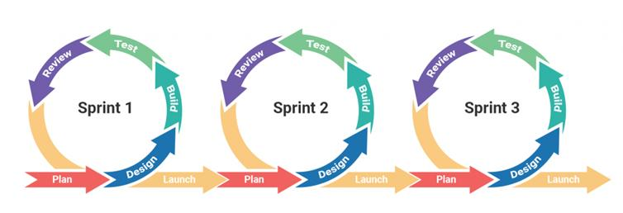

Sprints: The development timeline is divided into 2-week Sprints. Each sprint focuses on delivering a specific set of features (from the Product Backlog) that results in a potentially shippable product increment.

**Key Roles:**

* Product Owner (Leader): Responsible for defining the product vision, managing the Product Backlog, and prioritizing features based on stakeholder value.
* Scrum Master (Rotational/Assigned): Ensures the team adheres to Scrum practices, removes obstacles (blockers), and facilitates meetings.
* Development Team (All Members): Cross-functional members responsible for designing, coding, testing, and integrating the software.

**Scrum Ceremonies:**

* Sprint Planning (Day 1 of Sprint): The team selects items from the Product Backlog to work on during the sprint and breaks them down into tasks.
* Daily Stand-up (15 mins): A brief daily meeting where members report what they did yesterday, what they will do today, and any blockers they are facing.
* Sprint Review (Last Day of Sprint): The team demonstrates the completed work to supervisors/stakeholders to gather feedback.
* Sprint Retrospective (After Review): The team discusses what went well, what didn't, and how to improve processes for the next sprint.

### 2.2 Quality Management:

To ensure the "Learner Management and 3D Simulation System" meets high-quality standards and functional requirements, the team will implement the following quality assurance measures:

**Defect Prevention:**

* Coding Standards: The team will adhere to standard C# (.NET) and JavaScript (React) coding conventions to ensure code readability and maintainability.
* Static Code Analysis: Tools will be used in the IDE (Visual Studio/VS Code) to catch syntax errors and potential bugs early during development.
* Clear Requirements: All User Stories must have defined "Acceptance Criteria" before development begins to prevent misunderstanding.

**Reviewing:**

* Peer Code Reviews: All code changes must be submitted via Pull Requests (PR) on GitHub. At least one other team member must review the code for logic errors, style violations, and potential performance issues before it is merged into the main or develop branch.
* Document Reviews: Project documents (SRS, SDD) are reviewed by the Supervisor and team members to ensure consistency and completeness.

**Testing Strategy:**

* Unit Testing: Developers are responsible for writing unit tests for critical business logic, particularly for the API (Backend) services and complex Simulation algorithms.
* Integration Testing: Verifying that different modules work together correctly.
  + Web App: Testing communication between the React Frontend and .NET Backend APIs.
  + Simulation: Testing the data exchange between the Unity Desktop App and the Backend Server (e.g., login, score submission).
* System Testing (Functional Testing): The team will execute manual test cases based on the SRS to verify that the system functions as a whole and meets all user requirements (e.g., An instructor assigning a quiz, a trainee completing a simulation).
* User Acceptance Testing (UAT): Conducted near the end of the project (or Sprint Reviews) where the Supervisors/Instructors test the system to confirm it meets their business needs.

**Bug Tracking:**

* Defects found during testing will be logged in GitHub Issues or the project management tool (Jira/Excel) with a priority level (Critical, High, Medium, Low) and assigned to a developer for fixing.

### 2.3 Training Plan:

|  |  |  |  |
| --- | --- | --- | --- |
| **Training Area** | **Participants** | **When, Duration** | **Waiver Criteria** |
| Unity | All members | 2 weeks | Mandatory |
| Blender | All members | 2 weeks | Mandatory |
| ASP.NET | All members | 2 weeks | Mandatory |
| React | All members | 2 weeks | Mandatory |
| GitHub | All members | 2 weeks | Mandatory |

## 3. Project Deliverables:

|  |  |  |  |
| --- | --- | --- | --- |
| **#** | **Deliverable** | **Due Date** | **Notes** |
| 1 | Project Introduction document | 24/10/2025 | Overall project description |
| 2 | Project Management document | 26/10/2025 | Project estimation and management approach |
| 3 | SRS document | 05/11/2025 | Software Requirement Specification |
| 4 | Software Design Document | 15/11/2025 | System Design, Detailed Design, Database |
| 5 | Software Testing Document | 05/12/2025 | Test Document, Test Report |
| 6 | Final Report Document | 10/12/2025 | Project Final Report |
| 7 | Web Application | 10/12/2025 | Project Web Application Product |
| 8 | 3D Simulation Application | 10/12/2025 | Project Desktop Application Product |
| 9 | Source Code Repository | 10/12/2025 | Complete source code for all subsystems. |
| 10 | Project Package | 10/12/2025 | Final codes & documents |

## 4. Responsibility Assignments

D-Do; R-Review; S-Support; I-Informed; <blank>- Omitted

|  |  |  |  |  |
| --- | --- | --- | --- | --- |
| **Responsibility** | **NhatDNSE182236** | **DucDTSE180110** | **KhoiPDSE170462** | **QuangLNSE170415** |
| Project Introduction document | D | R | R | R |
| Project Management document | D | R | R | R |
| SRS Document | S | R | D | D |
| Software Design Document | D | S | D | R |
| Software Testing Document | R | S | R | D |
| Final Report Document | D | R | S | S |
| Web Application | D | R | D | D |
| 3D Simulation Application | R | D | R | S |
| Source Code Repository | D | R | R | R |
| Project Package | R | D | D | D |

## 5. Project Communications

|  |  |  |  |  |
| --- | --- | --- | --- | --- |
| **Communication Item** | **Who/ Target** | **Purpose** | **When, Frequency** | **Type, Tool, Method(s)** |
| Working with supervisor | Supervisors (Mr. Ngo Dang Ha An and Mr. Pham Thanh Tri) and team members | • Review  Project requirement and documentation  • Demonstrate  Major features  • Evaluate technologies, solutions and result | 1 time per week | Face to face, Google Meet |
| Working in team | Team members | • Specify tasks, reviews and opinions  • Ask for member’s help  • Report working  status to leader | Always | Discord, Zalo, Face to face |

## 6. Configuration Management

### 6.1 Document Management

* Using Google Drive to save documentations: [Documentations](https://drive.google.com/drive/folders/1WCULwKcoH_a3Fs3iA7kNoNuCjay2VSU2)
* Using Google Sheet to take notes: [Sheet notes](https://docs.google.com/spreadsheets/d/1T0FGoJQd6yg5hZ1aGeWRrXiEXOs_Av8wCk5YZ66LtnM/edit?gid=0" \l "gid=0)
* Using Draw.io to save design and diagrams: [Diagrams](https://app.diagrams.net/" \l "G1ZBxHY11O7l_lCcSxI_mZIU-oJc2f-xNk)

### 6.2 Source Code Management

* Using GitHub to store source code:
  + Backend API Repository: [github.com/hieuvau198/lssctc-api](https://github.com/hieuvau198/lssctc-api)
  + Frontend Web App Repository: [github.com/hieuvau198/lssctc-web](https://github.com/hieuvau198/lssctc-web)
  + Simulation Desktop App Repository: [github.com/hieuvau198/lssctc-simulator](https://github.com/hieuvau198/lssctc-simulator)
* Follow these rules when using Git:
  + Commit convention:
    - Commit code with syntax: git commit -m "type: what-commit-does"
    - Types of commits include:
      * feat: new feature
      * fix: handle bug
      * config: change related to config file
      * docs: changes related to config file documentation
      * test: adding testing code
  + Pull request convention:
    - Attach a link to the task on Notion in the description of the pull request.
    - Do not push code directly to main/master branch. Let’s create a new branch for every new task.
    - Tag the leader for code review.

### 6.3 Tools & Infrastructures

|  |  |
| --- | --- |
| **Category** | **Tools / Infrastructure** |
| **Technology** | Unity (Simulator), Blender (Modelling), .NET (Backend), React (frontend) |
| **Database** | Microsoft SQL Server |
| **IDEs/Editors** | Visual Studio, Visual Studio Code |
| **Diagramming** | Draw.io, Lucid chart |
| **Documentation** | Ms Office, Google Docs/Sheets |
| **Version Control** | GitHub (Source Codes), Google Drive (Documents) |
| **Deployment server** | Microsoft Azure |
| **Project management** | Jira, Google Sheets |

# III. Software Requirement Specification

## 1. Product Overview

The Learner Management and 3D Simulation System for Crane Training Center (LSSCTC) is an integrated software suite designed to address the high costs, significant safety risks, and logistical challenges of traditional crane operation training. The system provides a unified solution for both theoretical and simulated practical training.

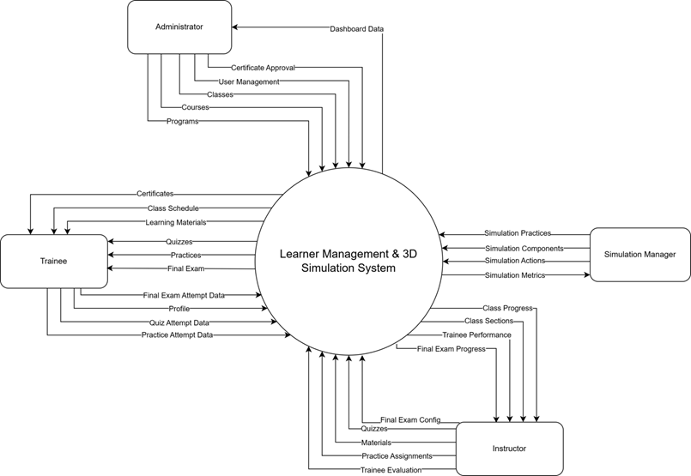

## 2. User Requirements

### 2.1 Actors

|  |  |  |
| --- | --- | --- |
| **#** | **Actor** | **Description** |
| 1 | Administrator | The Administrator is the top-level user responsible for the overall system setup and user management. Using the web application, they manage all user accounts, create and organize the academic structure by managing programs, courses, and classes. |
| 2 | Simulation Manager | The Simulation Manager is responsible for defining all aspects of the 3D simulation content. They manage the simulation practices, including simulation components, actions, and warnings. |
| 3 | Instructor | The instructor is responsible for managing the content and trainees within their assigned classes. Using the web application, they manage class members, organize class sections, and upload learning materials and quizzes. They also assign simulation practices to the class and are responsible for tracking trainee results, providing feedback, and confirming the final status for each trainee. |
| 4 | Trainee | The Trainee is the primary learner in the system. They use the web application to manage their profile, enroll in classes, access learning materials, and complete theoretical quizzes. They also use the separate 3D simulation desktop application to log in and perform practical crane simulation exercises. |

### 2.2 Use Case

#### 2.2.1 Use Case Diagram

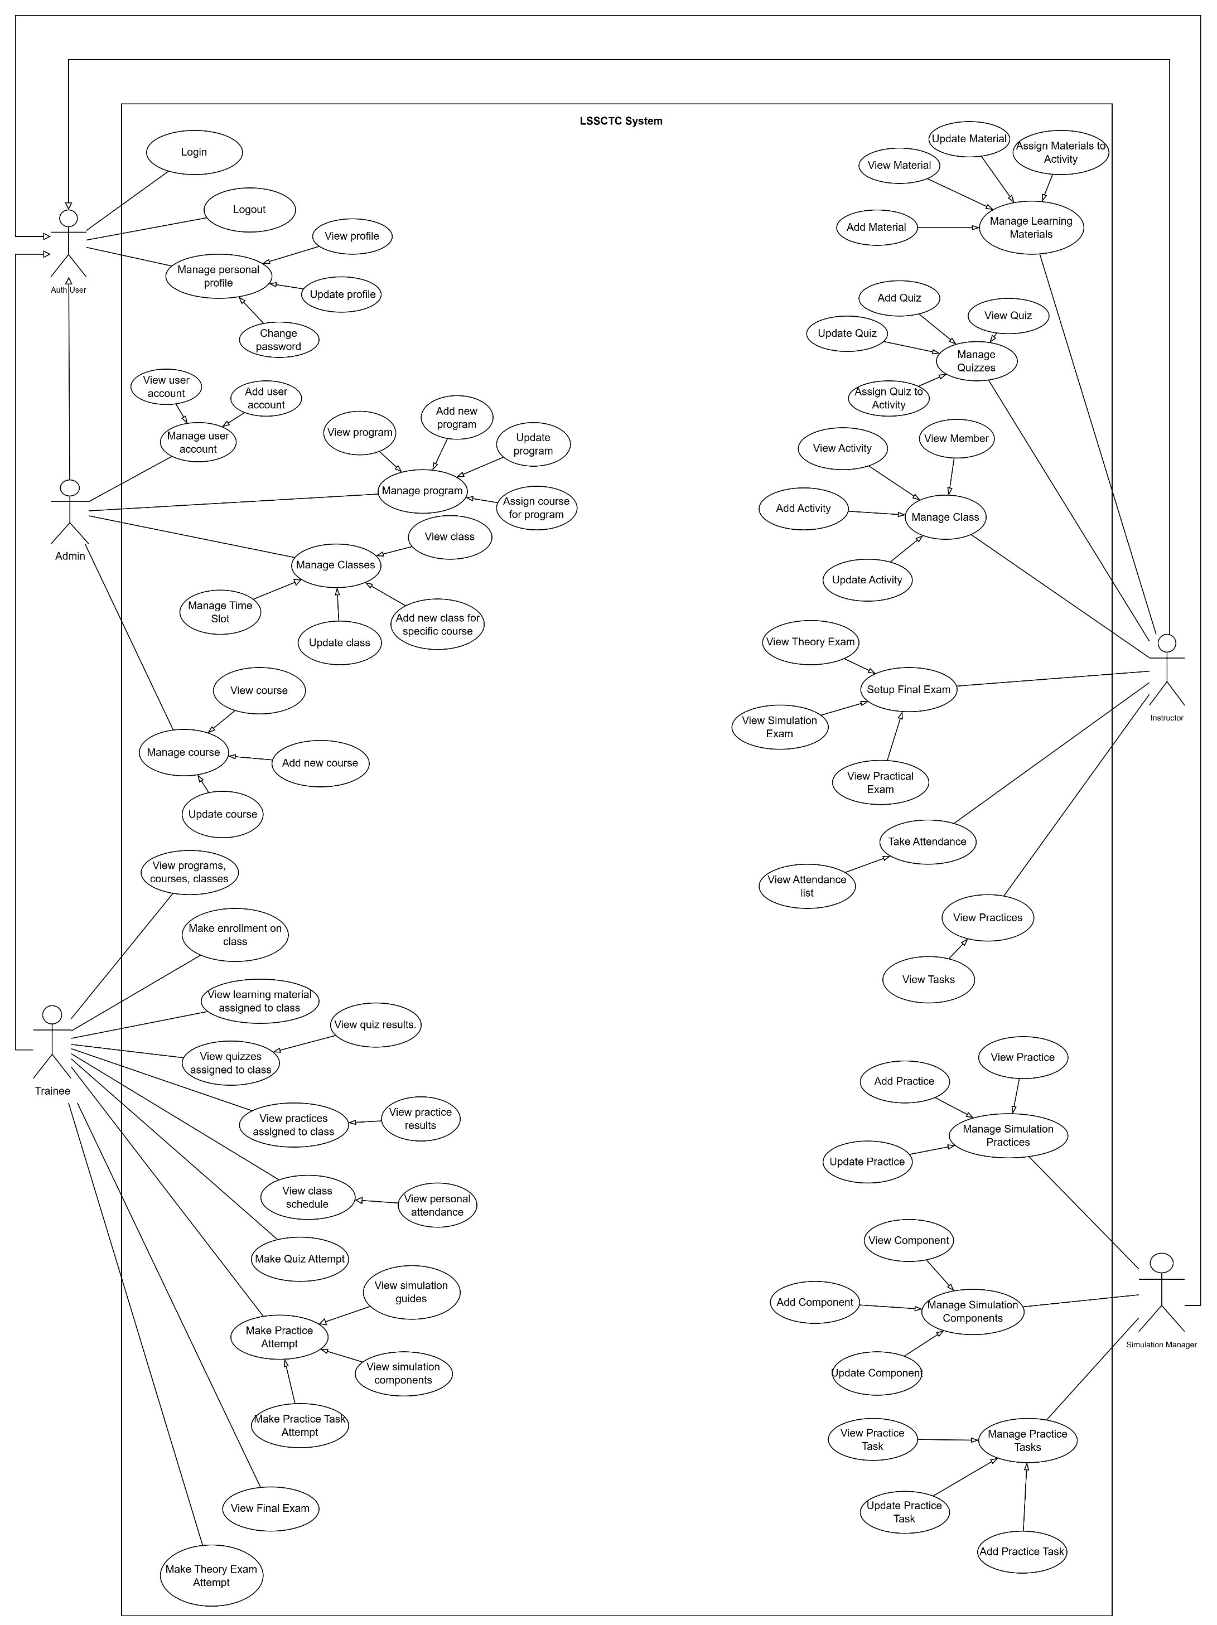

#### 2.2.2 Descriptions

|  |  |  |  |
| --- | --- | --- | --- |
| **ID** | **Use Case** | **Actors** | **Use Case Description** |
| UC-01 | Add Material | Instructor | This feature allows instructor add a new learning material (PDF, video, link) for teaching. |
| UC-02 | Update Material | Instructor | This feature allows instructor update an existing learning material’s info or file. |
| UC-03 | View Material | Instructor | This feature allows instructor view the list and details of learning materials. |
| UC-04 | Assign Materials to Section | Instructor | This feature allows instructor link selected materials to a section/partition for trainees to access. |
| UC-05 | Add Quiz | Instructor | This feature allows instructor create a new quiz with basic information. |
| UC-06 | Update Quiz | Instructor | This feature allows instructor edit a quiz’s information. |
| UC-07 | View Quiz | Instructor | This feature allows instructor view quizzes and their details. |
| UC-08 | Assign Quiz to Section | Instructor | This feature allows instructor attach a quiz to a specific section/partition for delivery. |
| UC-09 | Add Member | Instructor | This feature allows instructor add a trainee to the class roster. |
| UC-10 | View Member | Instructor | This feature allows instructor view trainee profiles and class membership. |
| UC-11 | Track Member Process | Instructor | This feature allows instructor track each trainee’s study progress and results. |
| UC-12 | View Section | Instructor | This feature allows instructor track each trainee’s study progress and results. |
| UC-13 | Add Section | Instructor | This feature allows instructor create a new section for the class. |
| UC-14 | Update Section | Instructor | This feature allows instructor edit section information. |
| UC-15 | Assign Practices to Section | Instructor | This feature allows instructor link practice activities to a section/partition. |
| UC-16 | View Practices | Instructor | This feature allows instructor view practice list and details in the class/section. |
| UC-17 | Confirm Pass/Fail Results | Instructor | This feature allows instructor view practice list and details in the class/section. |
| UC-18 | Add Practice | Instructor | This feature allows instructor create a new practice activity. |
| UC-19 | Update Practice | Instructor | This feature allows instructor edit an existing practice activity. |
| UC-20 | View Practices | Instructor | This feature allows instructor view details of a specific practice activity. |
| UC-21 | Add Component | Instructor | This feature allows instructor add a simulation component needed for practice. |
| UC-22 | Update Component | Instructor | This feature allows instructor update a simulation component’s information. |
| UC-23 | View Component | Instructor | This feature allows instructor view the list and details of simulation components. |
| UC-24 | Add Action | Instructor | This feature allows instructor add a simulation action/step used in practices. |
| UC-25 | Update Action | Instructor | This feature allows instructor update a simulation action/step. |
| UC-26 | View Action | Instructor | This feature allows instructor view the list and details of simulation actions. |
| UC-27 | Add Component | Simulation Manager | This feature allows the simulation manager to add a new simulation component to the system. |
| UC-28 | Update Component | Simulation Manager | This feature allows the simulation manager to edit or update existing simulation component information. |
| UC-29 | View Component | Simulation Manager | This feature allows the simulation manager to view the list and details of simulation components. |
| UC-30 | Add Action | Simulation Manager | This feature allows the simulation manager to add a new simulation action used in training practices. |
| UC-31 | Update Action | Simulation Manager | This feature allows the simulation manager to edit or update existing simulation actions. |
| UC-32 | View Action | Simulation Manager | This feature allows the simulation manager to view the list and details of simulation actions. |
| UC-33 | Add Slot | Simulation Manager | This feature allows the simulation manager to create a new simulation timeslot for scheduling practices. |
| UC-34 | Update Slot | Simulation Manager | This feature allows the simulation manager to update or reschedule an existing simulation timeslot. |
| UC-35 | View Slot | Simulation Manager | This feature allows the simulation manager to view all simulation timeslots and their details. |
| UC-36 | Assign Practice to Slot | Simulation Manager | This feature allows the simulation manager to assign a specific practice activity to a simulation timeslot. |
| UC-37 | Add Practice Step | Simulation Manager | This feature allows the simulation manager to define and add new steps for a practice scenario. |
| UC-38 | Update Practice Step | Simulation Manager | This feature allows the simulation manager to modify or reorder steps within a practice scenario. |
| UC-39 | View Practice Step | Simulation Manager | This feature allows the simulation manager to view practice steps assigned to each practice activity. |
| UC-40 | Add Warning | Simulation Manager | This feature allows the simulation manager to create new warning messages or alerts for simulation steps. |
| UC-41 | Update Warning | Simulation Manager | This feature allows the simulation manager to modify or remove existing simulation warnings. |
| UC-42 | View Warning | Simulation Manager | This feature allows the simulation manager to view all defined warnings and their details. |
| UC-43 | Make enrollment programs/courses/classes | Trainee | This feature allows trainee submit an enrolment request to a program, course, or class. |
| UC-44 | View programs, courses, classes | Trainee | This feature allows trainee view the catalog and details of available programs, courses, and classes. |
| UC-45 | Access learning material | Trainee | This feature allows trainee access learning materials provided for their study. |
| UC-46 | View learning material assigned to class section | Trainee | This feature allows trainee view materials specifically assigned to their class section. |
| UC-47 | Download material | Trainee | This feature allows trainee download learning files for offline use. |
| UC-48 | View quizzes assigned to class section | Trainee | This feature allows trainee see newly assigned quizzes for their section. |
| UC-49 | Make attempt quizzes | Trainee | This feature allows trainee start and submit a quiz attempt. |
| UC-50 | View recorded results | Trainee | This feature allows trainee view their quiz scores and attempt history. |
| UC-51 | View practices assigned to class section | Trainee | This feature allows trainee view the list of practices assigned to their section. |
| UC-52 | Select a practice to make a new attempt | Trainee | This feature allows trainee choose a practice and create a new attempt. |
| UC-53 | View list practices | Trainee | This feature allows trainee browse the practice list available to them. |
| UC-54 | Settings simulation guides | Trainee | This feature allows trainee configure guidance options and hints for simulation. |
| UC-55 | View simulation guides | Trainee | This feature allows trainee read the simulation guidance before or during practice. |
| UC-56 | View practice steps and step details | Trainee | This feature allows trainee review each step and its detailed instructions. |
| UC-57 | View simulation components | Trainee | This feature allows trainee view components used in the simulation scenario. |
| UC-58 | Perform simulation actions | Trainee | This feature allows trainee perform the required actions in the simulator. |
| UC-59 | View post-practice result | Trainee | This feature allows trainee see overall results after completing a practice. |
| UC-60 | View step result and warning message | Trainee | This feature allows trainee check each step’s result and any warning messages. |
| UC-61 | View user account | Admin | This feature allows admin view the list and details of user accounts in the system. |
| UC-62 | Add user account | Admin | This feature allows admin create a new user account and assign a role. |
| UC-63 | Deactivate user account | Admin | This feature allows admin deactivate or disable a user account. |
| UC-64 | Manage user account | Admin | This feature allows admin manage all user accounts, including creating, viewing, and deactivating users. |
| UC-65 | View program | Admin | This feature allows admin view the list and details of existing training programs. |
| UC-66 | Add new program | Admin | This feature allows admin create a new training program in the system. |
| UC-67 | Update program | Admin | This feature allows admin edit information of an existing training program. |
| UC-68 | Assign course for program | Admin | This feature allows admin assign specific courses to a training program. |
| UC-69 | Manage program | Admin | This feature allows admin manage all training programs, including viewing, updating, and course assignment. |
| UC-70 | View class | Admin | This feature allows admin view the list and details of all classes in the system. |
| UC-71 | Add new class for specific course | Admin | This feature allows admin create a new class linked to a selected course. |
| UC-72 | Update class | Admin | This feature allows admin modify class information such as schedule or instructor. |
| UC-73 | Manage classes | Admin | This feature allows admin manage all classes, including creating, updating, and viewing them. |
| UC-74 | View course | Admin | This feature allows admin view the list and details of all courses in the system. |
| UC-75 | Add new course | Admin | This feature allows admin create a new course record in the system. |
| UC-76 | Update course | Admin | This feature allows admin edit the details of an existing course. |
| UC-77 | Manage course | Admin | This feature allows admin manage all courses, including adding, updating, and viewing them. |
| UC-78 | View programs, courses, classes | Admin | This feature allows admin view an overview list of all programs, courses, and classes in the system. |
| UC-79 | Login | Auth User | This feature allows user login to the system by verifying their credentials and accessing authorized functions. |
| UC-80 | Logout | Auth User | This feature allows user logout from the system securely and end their session. |
| UC-81 | View profile | Auth User | This feature allows user view their personal profile information stored in the system. |
| UC-82 | Update profile | Auth User | This feature allows user edit and update their personal profile details. |
| UC-83 | Change password | Auth User | This feature allows user change their password for account security. |
| UC-84 | Manage personal profile | Auth User | This feature allows user manage their personal profile, including viewing, editing, and changing password. |

## 3. Functional Requirements

### 3.1 System Functional Overview

#### 3.1.1 Screens Flow

##### 3.1.1.1 Admin Flow

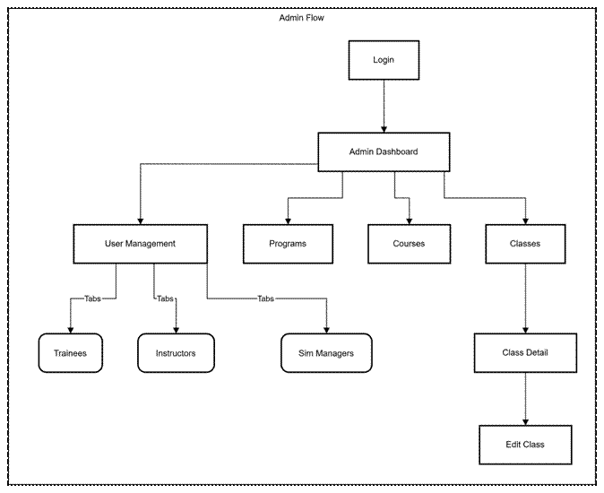

##### 3.1.1.2 Trainee Flow

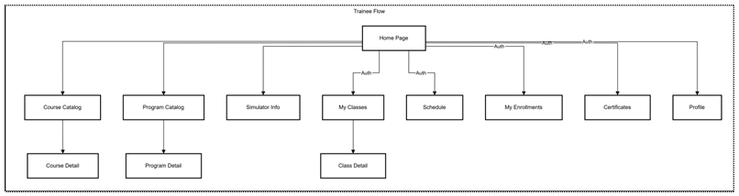

##### 3.1.1.2 Instructor Flow

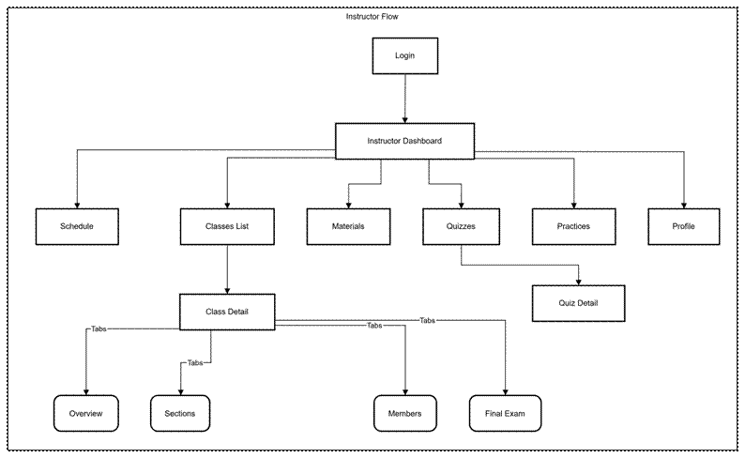

##### 3.1.1.2 Simulation Manager Flow

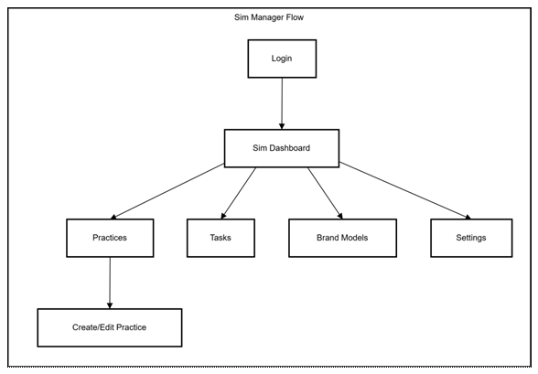

#### 3.1.2 Screen Descriptions

|  |  |  |  |
| --- | --- | --- | --- |
| **#** | **Feature** | **Screen** | **Description** |
| 1 | Dashboard | Admin Dashboard | Overview of system statistics, user counts, and recent activities for Administrators. |
| 2 | Dashboard | Instructor Dashboard | Overview of assigned classes, upcoming schedules, and student performance metrics. |
| 3 | Dashboard | Sim Manager Dashboard | Status overview of active simulations, practice scenarios, and system health. |
| 4 | User Management | User Lists | Interfaces to view and manage Trainees, Instructors, and Simulation Managers (tabs/tables). |
| 5 | Program Management | Program List | Management of training programs, including creation and modification. |
| 6 | Program Management | Program Catalog | Public view for trainees to browse available training programs. |
| 7 | Course Management | Course List (Admin) | Administrative list of all courses to manage details and curriculum. |
| 8 | Course Management | Course Catalog | Public view for trainees to browse and view details of specific courses. |
| 9 | Class Management | Class Management (Admin) | List of classes for admins to create, edit, or view detailed class information. |
| 10 | Class Management | Instructor Classes | List of classes assigned to the instructor for teaching. |
| 11 | Class Management | My Classes (Trainee) | List of classes the trainee is currently enrolled in. |
| 12 | Class Management | Class Detail | Detailed view of a specific class (Overview, Sections, Members, Schedule, Exams). |
| 13 | Class Management | Schedule | Calendar view of teaching (Instructor) or learning (Trainee) sessions. |
| 14 | Class Management | Quizzes | Management of quizzes, including creation and editing questions (Instructor). |
| 15 | Class Management | Final Exam | Management and grading of final exams for a class. |
| 16 | Simulation | Practices Management | Creation and configuration of simulation practice scenarios and steps. |
| 17 | Simulation | Brand Models | Configuration of brand models used within simulations. |
| 18 | Class Management | Materials | Management of learning materials and resources for courses. |
| 19 | User Management | User Profile | View and edit personal account information. |

#### 3.1.3 Screen Authorization

|  |  |  |  |  |
| --- | --- | --- | --- | --- |
| **Screen** | **Admin** | **Instructor** | **Trainee** | **Sim Manager** |
| Admin Dashboard | X |  |  |  |
| Manage Users (Trainees, Instructors, etc.) | X |  |  |  |
| Manage Programs & Courses (Admin) | X |  |  |  |
| Manage Classes (Admin) | X |  |  |  |
| Instructor Dashboard |  | X |  |  |
| Instructor Schedule |  | X |  |  |
| Teaching Classes (List & Detail) |  | X |  |  |
| Class Attendance & Grading |  | X |  |  |
| Content Management (Materials, Sections) |  | X |  |  |
| Assessment Management (Quizzes, Practices) |  | X |  |  |
| My Classes (Trainee) |  |  | X |  |
| My Enrollments |  |  | X |  |
| Trainee Schedule |  |  | X |  |
| Certificates |  |  | X |  |
| Sim Manager Dashboard |  |  |  | X |
| Manage Practices & Tasks |  |  |  | X |
| Manage Brand Models |  |  |  | X |
| Simulation Settings |  |  |  | X |

#### 3.1.4 Non-Screen Functions

|  |  |  |  |
| --- | --- | --- | --- |
| **#** | **Feature** | **System Function** | **Description** |
| 1 | **Authentication** | Token Interception & Injection | Automatically intercepts outgoing API requests to inject the JWT authentication token into the headers, ensuring secure communication with the backend. |
| 2 | **Security** | Role-Based Access Control (RBAC) | Validates the current user's role against the allowed roles defined for each protected route. If the user lacks permission, it automatically redirects them to the login page or a forbidden page. |
| 3 | **State Management** | Global Session Store | Maintains the user's active session state (including profile data, role, and avatar URL) across different pages without requiring repeated API calls, using a client-side store (Zustand). |
| 4 | **Localization** | Dynamic Language Switching | Manages the application's locale settings, dynamically swapping text resources between English (en) and Vietnamese (vi) and persisting the preference without reloading the page. |
| 5 | **Data Persistence** | Cookie Management | Handles the secure storage and retrieval of authentication tokens and user preferences in browser cookies, allowing sessions to persist across browser restarts. |
| 6 | **Utility** | Time Slot Status Calculation | Automatically calculates the status of a schedule slot (e.g., "Present", "Past", "Future") based on the current system time compared to the slot's start and end times, used for rendering calendar interfaces. |

#### 3.1.5 Entity Relationship Diagram

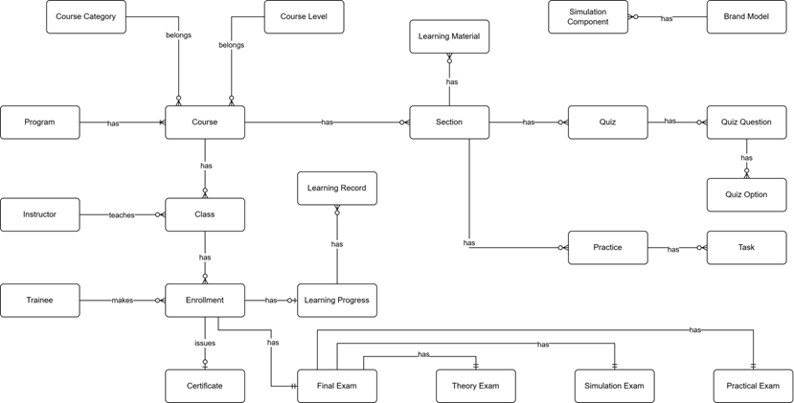

### 

#### 3.1.6 Entity Relationship Description

|  |  |  |
| --- | --- | --- |
| **#** | **Entity** | **Description** |
| 1 | Course Category | Classification or categorization of courses by subject area or domain (e.g., Basic Crane Operations, Safety Procedures, Advanced Techniques). Provides organizational structure for grouping related courses. Each course belongs to one category. |
| 2 | Course Level | Defines the difficulty or skill level of a course (e.g., Entry Level, Intermediate, Advanced). Used to establish learning progression paths and prerequisite requirements. Each course is assigned one level to indicate target trainee proficiency. |
| 3 | Program | Comprehensive training program consisting of multiple courses designed to achieve specific certification or skill objectives. Programs define structured learning paths for trainees, combining courses in a logical sequence to build competencies for crane operator certification. |
| 4 | Course | Individual training course representing a specific subject or skill area within the crane training curriculum. Contains course content structured into sections, can be assigned to multiple programs, and serves as the foundation for class creation. Belongs to one category and one level. |
| 5 | Instructor | Teaching staff member responsible for delivering course instruction, managing class activities, creating learning materials and assessments, and evaluating trainee performance. Instructors are assigned to teach specific classes and provide guidance throughout the learning process. |
| 6 | Class | Scheduled instance of a course with defined start/end dates, assigned instructor, and enrolled trainees. Represents the actual delivery of course content to a specific group of trainees. Classes are where learning activities, assessments, and instruction occur. |
| 7 | Trainee | Student or learner enrolled in training programs to become certified crane operators. Trainees make enrollments in classes, access learning materials, complete quizzes and practices, take final exams, and track their learning progress toward certification. |
| 8 | Enrollment | Record of a trainee's registration in a specific class. Creates the relationship between trainee and class, enabling access to course materials, activities, and assessments. Enrollment triggers creation of learning progress tracking and final exam records. |
| 9 | Learning Material | Educational content resources such as videos, documents, presentations, or external links used to deliver course instruction. Materials are assigned to sections to provide trainees with reference and study resources. Can be reused across multiple sections. |
| 10 | Section | Logical unit or module within a course syllabus representing a specific topic or learning objective. Sections organize course content into manageable chunks and contain learning materials, quizzes, and practices. Defines the structure and sequence of course curriculum. |
| 11 | Quiz | Assessment tool containing multiple questions used to evaluate trainee understanding of theoretical concepts. Quizzes are assigned to sections, have defined pass criteria and time limits, and contribute to overall learning progress. Results are tracked through quiz attempts. |
| 12 | Quiz Question | Individual question within a quiz presenting a problem or prompt for trainees to answer. Questions are assigned point values (contributing to total quiz score of 10 points) and can support single or multiple correct answers through associated quiz options. |
| 13 | Quiz Option | Possible answer choice for a quiz question. Each option is marked as correct or incorrect and may have associated explanations. Multiple options per question enable various question types (multiple choice, select all that apply). |
| 14 | Practice | Simulation-based training scenario performed in the 3D crane simulator environment. Practices consist of ordered tasks that trainees must complete to demonstrate hands-on skills. Assigned to sections as practical learning activities with defined difficulty levels and attempt limits. |
| 15 | Task | Individual step or action within a simulation practice that trainees must perform correctly. Tasks define expected results for validation, and task completion is tracked during practice attempts. Tasks are reusable components across different practices. |
| 16 | Simulation Component | 3D virtual representation of crane parts, controls, or environment objects used in simulation practices. Components are linked to brand models to represent real-world equipment and are referenced in tasks for interaction requirements. |
| 17 | Brand Model | Specification of real crane equipment brands and models being simulated in the training system. Defines manufacturer information, specifications, and links to simulation components that represent the physical equipment in virtual environment. |
| 18 | Learning Record | Historical record of trainee interactions with course sections, tracking what content has been accessed and when. Maintains audit trail of learning activities for compliance, reporting, and progress monitoring purposes. |
| 19 | Learning Progress | Comprehensive tracking of trainee advancement through enrolled courses. Records overall progress percentage, theory and practical scores, completion status, and timestamps. Central entity for monitoring trainee performance and determining certification readiness. |
| 20 | Certificate | Official document template awarded to trainees upon successful course or program completion. Defines certificate design, content structure, and requirements. Issued certificates are permanent records of trainee achievement for verification and credentialing purposes. |
| 21 | Final Exam | Comprehensive assessment conducted at course completion to evaluate trainee readiness for certification. Consists of three components (Theory, Practical, Simulation) that are weighted and combined for total score. Results determine pass/fail status and certificate eligibility. |
| 22 | Theory Exam | Written assessment component of final exam evaluating trainee understanding of theoretical concepts and safety knowledge. Implemented using the quiz system with defined pass criteria. One of three partial exams that compose the final exam. |
| 23 | Simulation Exam | Performance-based assessment component conducted in 3D simulator requiring trainees to demonstrate crane operation skills. Uses practice system with task-by-task evaluation. One of three partial exams contributing to final exam score and certification decision. |
| 24 | Practical Exam | Hands-on assessment component where trainees demonstrate physical crane operation skills evaluated by instructors using predefined checklists. Assesses real-world competencies beyond simulation environment. One of three partial exams required for certification. |

## 4. Non-Functional Requirements

### 4.1 Security

* NFR-SEC-01 (Authentication): The system must use JWT (JSON Web Tokens) for stateless, secure API authentication.
* NFR-SEC-02 (Token Management): The system must support token revocation (blacklist) using Distributed Cache to prevent usage of compromised tokens before expiry.
* NFR-SEC-03 (Data Protection): Sensitive data (like passwords) must be hashed. The API must communicate over HTTPS (though RequireHttpsMetadata is currently false for dev, production requires true).
* NFR-SEC-04 (Access Control): API endpoints must be protected by Role-Based Authorization policies ensuring users can only access data pertinent to their role.

### 4.2 Performance & Scalability

* NFR-PERF-01: The system uses Distributed Memory Cache to handle high-frequency data access like token validation and OTP storage.
* NFR-PERF-02: Database interactions must use asynchronous operations (async/await) to prevent thread blocking under load.
* NFR-PERF-03: Large data sets (Users, Classes, Enrolments) must be returned via Pagination (Paged Result) to reduce network payload and database load.

### 4.3 Interoperability & Compatibility

* NFR-INT-01: The API must expose a Swagger/OpenAPI documentation interface for client integration.
* NFR-INT-02: The system must support CORS (Cross-Origin Resource Sharing) to allow requests from specific web clients (e.g., lssctc.site, localhost).
* NFR-INT-03: The system must support standard file formats for imports/exports, specifically Excel (.xlsx) and CSV.

### 4.4 Availability & Reliability

* NFR-REL-01: The system is built on .NET Core and Entity Framework Core, designed for cross-platform deployment.
* NFR-REL-02: External integrations (e.g., Email Service) must be implemented as Transient services to ensure fresh connections and reliability.

## 5. Business Rules

|  |  |  |
| --- | --- | --- |
| **ID** | **Category** | **Rule Definition** |
| BR-01 | Authentication | Upon successful login to the **web app**, the system **must** redirect users to their role-based landing page:  - **Admin:** Admin Dashboard  - **Simulation Manager:** Simulation Manager Dashboard  - **Instructor:** Instructor Dashboard  - **Trainee:** Trainee Home Page |
| BR-02 | Authentication | Upon successful login to the **simulation app**, users with the 'Trainee' role **must** be redirected to the home screen. |
| BR-03 | Authentication | Deactivated accounts **cannot** log in or interact with the system. |
| BR-04 | Authentication | The Username, Email, and Phone Number fields **must** be unique for each user account. |
| BR-05 | Authentication | A user's Phone Number **must** be between 4 and 15 digits. |
| BR-06 | Authentication | The Email field **must** adhere to a standard email format (e.g., [user@domain.com](mailto:user@domain.com)). |
| BR-07 | Authentication | A user's account profile **can** only be updated by the account owner. |
| BR-07 | Authentication | A password reset request **must** require email verification. |
| BR-08 | Permissions | The 'Admin' role has exclusive permissions to manage 'Simulation Manager', 'Instructor', and 'Trainee' accounts. |
| BR-09 | Permissions | The 'Admin' role has exclusive permissions to:  - Create and update programs.  - Assign courses to a program.  - Create and update courses.  - Create and update course syllabi.  - Manage classes. |
| BR-10 | Permissions | Instructors **can** only manage content for classes to which they are assigned. |
| BR-11 | Programs | A new program **must** be created with a Name and an Active Status. |
| BR-12 | Programs | A program **cannot** contain duplicate course assignments. |
| BR-13 | Programs | A program **cannot** be assigned more than 10 courses. |
| BR-14 | Courses | Each course **must** have a unique Name and a unique Course Code. |
| BR-15 | Courses | A new course **must** be created with a Name, Course Code. |
| BR-16 | Courses | A course’s learning section **can** only be updated if no classes are currently assigned to that course. |
| BR-17 | Classes | Each class **must** have a unique Name and a unique Class Code. |
| BR-18 | Classes | A class **must** be linked to a specific course upon creation. |
| BR-19 | Classes | A class **must** have exactly one assigned 'Instructor'. |
| BR-20 | Classes | Before a class starts, its learning content **must** mirror the learning sections of its parent course. |
| BR-21 | Classes | Class content **can** only be updated when class status is ‘Draft’ or ‘Open’. |
| BR-22 | Classes | A class **can** only be started if all conditions are met:  - At least one 'Trainee' is enrolled.  - One 'Instructor' is assigned only.  - Every class section contains at least one activity. |
| BR-23 | Classes | Each class **must** have a unique Name and a unique Class Code. |
| BR-24 | Trainee | A 'Trainee' **must** have a valid account before enrolling in any program. |
| BR-25 | Trainee | A 'Trainee' **cannot** be enrolled in the same class more than once. |
| BR-26 | Trainee | A 'Trainee' **cannot** be enrolled in two different classes that have conflicted schedules. |
| BR-27 | Trainee | 'Trainees' **can only attempt quiz and practice when their session is valid**. |
| BR-28 | Class Activities | Each learning activity **must** be one of the following types: 'Material', 'Quiz', or 'Practice'. |
| BR-29 | Class Activities | A new activity **must** be created with a Name, Type, and Order (sequence) number. |
| BR-30 | Class Activities | A new learning material (e.g., 'Video', 'Document') **must** include a Name and either a Source File or Source URL. |
| BR-31 | Class Activities | A Source File for learning material **cannot** exceed 50MB in size. |
| BR-32 | Quizzes | A new quiz **must** be created with a Name and a Max Attempts value. |
| BR-33 | Quizzes | A quiz **must** contain one or more questions. |
| BR-34 | Quizzes | Each question **must** include answer options, and each option **must** be flagged as 'Correct' or 'Incorrect'. |
| BR-35 | Quizzes | A quiz **cannot** contain more than 100 questions. |
| BR-36 | Quizzes | A quiz question **cannot** have more than 20 answer options. |
| BR-37 | Quizzes | The total score for every quiz **must** be exactly 10 points. |
| BR-38 | Quizzes | The score of any single question **must** be greater than 0 and less than 10. |
| BR-39 | Quizzes | The sum of all question scores within a quiz **must** equal 10. |
| BR-40 | Quizzes | Only users with the 'Trainee' role **can** attempt a quiz. |
| BR-41 | Quizzes | Every quiz attempt by a 'Trainee' **must** be recorded. |
| BR-42 | Quizzes | A 'Trainee's' final quiz score **must** be determined by their latest attempt. |
| BR-43 | Quizzes | 'Trainees' **cannot** retake a quiz after reaching the Max Attempts limit. |
| BR-44 | Simulation Practices | A simulation practice **must** contain between 1 and 20 tasks. |
| BR-45 | Simulation Practices | Each practice task **must** have a unique ‘task\_code’. |
| BR-46 | Simulation Practices | Each practice must have a unique ‘practice\_code’. |
| BR-47 | Simulation Practices | A task cannot be assigned to a practice more than once. |
| BR-48 | Simulation Practices | A new practice task **must** be created with a Name, Description, and Task Code. |
| BR-49 | Simulation Practices | A new simulation practice **must** have a unique Name and a unique Practice Code. |
| BR-50 | Simulation Practices | A new simulation Component **must** have a unique Name, and a unique Component Code. |
| BR-51 | Simulation Practices | 'Trainees' **must** be authenticated before accessing a simulation practice. |
| BR-52 | Simulation Practices | 'Trainees' **can** only start practices that are marked as 'Active' and are part of their assigned class. |
| BR-53 | Simulation Practices | 'Trainees' **must** complete all simulation tasks to finish a practice. |
| BR-54 | Simulation Practices | While a 'Trainee' is taking a simulation practice:  - The system **must** display guides and step descriptions.  - The system **must** automatically advance to the next step upon successful completion of the current step.  - The system **must** record the result of every step for evaluation. |
| BR-55 | Simulation Practices | 'Trainees' **cannot** retake a simulation practice after reaching the Max Attempts limit. |
| BR-56 | Simulation Practices | 'Trainees' **must** be authenticated before accessing a simulation practice. |
| BR-57 | Simulation Practices | 'Trainees' **can** only start a simulation final exam after input a correct Exam Code. |
| BR-58 | Simulation Practices | 'Trainees' **can only access to the simulation final exam belongs to their enrolled classes.** |
| BR-59 | Simulation Practices | While a 'Trainee' is taking a simulation final exam:  - The system **must** display guides and step descriptions.  - The system **must** automatically advance to the next task upon successful completion of the current step.  - The system **must** record the result of every task for evaluation. |
| BR-60 | Simulation Practices | 'Trainees' **cannot** retake a simulation final exam after reaching the Max Attempts limit. |

# IV. Software Design Description

## 1. System Design

### 1.1 System Architecture Diagram

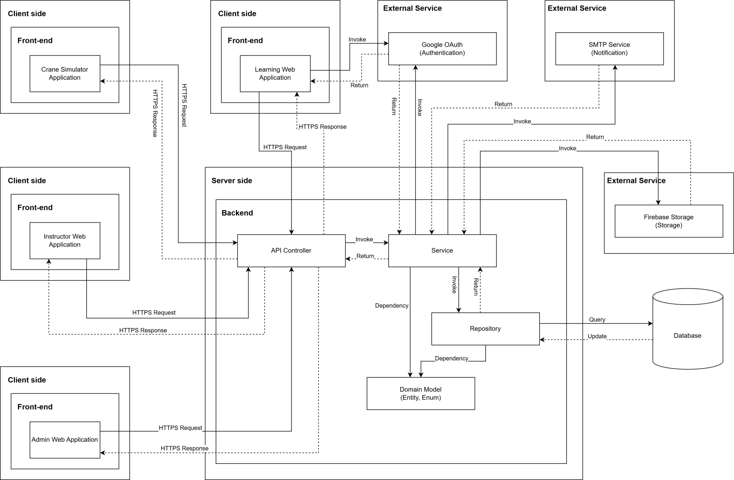

***System Architecture Diagram Descriptions***

|  |  |  |
| --- | --- | --- |
| **No** | **Name** | **Description** |
| 1 | Crane Simulator Application | Desktop application for practical crane operation training, communicates with backend via HTTPS to access training content and submit practice results |
| 2 | Learning Web Application | Web-based application for trainees to access learning materials, complete courses, take quizzes, and track their learning progress |
| 3 | Instructor Web Application | Web application for instructors to manage classes, create and grade quizzes, provide feedback, and monitor student progress |
| 4 | Admin Web Application | Web application for administrators to manage users, programs, courses, system settings, and overall platform administration |
| 5 | API Controller | RESTful API layer that receives HTTPS requests from client applications, routes them to appropriate services, and returns responses |
| 6 | Service | Business logic layer containing core application logic, processing business rules, orchestrating workflows, and coordinating between controllers and repositories |
| 7 | Repository | Data access layer that abstracts database operations, handles CRUD operations, and manages data persistence using Entity Framework or similar ORM |
| 8 | Domain Model (Entity, Enum) | Domain entities and enumerations representing the core business objects and data structures (Users, Courses, Classes, Quizzes, etc.) |
| 9 | Database | SQL Server database storing all system data including users, courses, enrollments, quiz attempts, practice results, and certificates |
| 10 | Google OAuth (Authentication) | External authentication service for user login using Google accounts, providing secure OAuth 2.0 authentication flow |
| 11 | SMTP Service (Notification) | External email service for sending notifications, alerts, password resets, and course-related communications to users |
| 12 | Firebase Storage (Storage) | Cloud storage service for storing and serving media files including course materials, videos, images, documents, and user-uploaded content |

### 1.2 Component Diagram

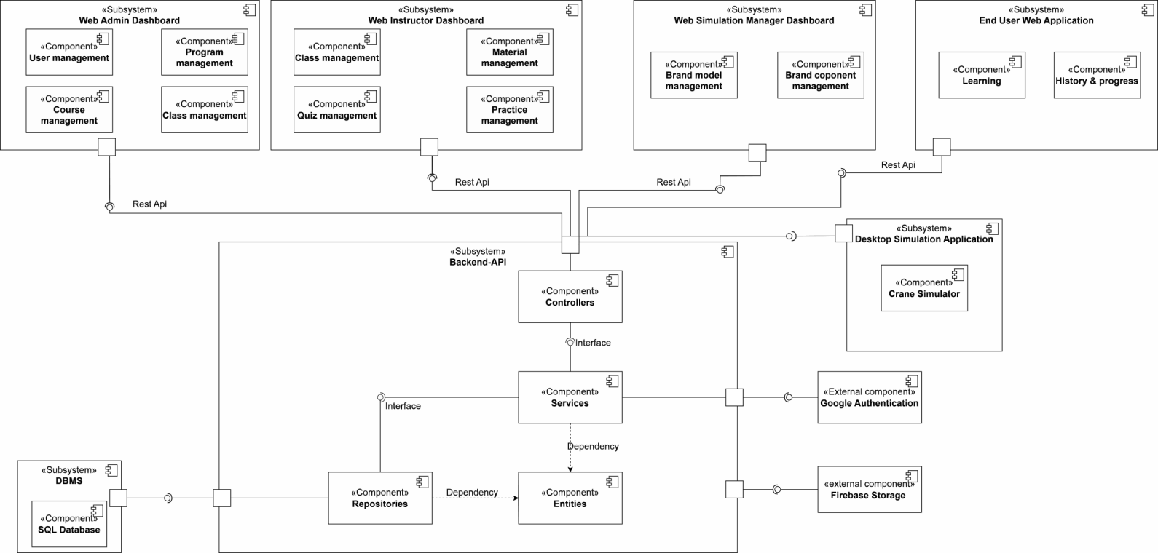

***Component Diagram Descriptions***

|  |  |  |
| --- | --- | --- |
| **No** | **Name** | **Description** |
| 1 | Web Admin Dashboard | Web administrative interface for Admin, including user management, program management, and course management features |
| 2 | User management | Component for managing users, handling account information, permissions, and user administration in the system |
| 3 | Program management | Component for managing training programs, organizing courses and curriculum |
| 4 | Course management | Component for managing courses, learning content, lectures, and materials |
| 5 | Web Instructor Dashboard | Web interface for instructors, including class management and quiz management |
| 6 | Class management | Component for managing classes, student lists, schedules, and attendance |
| 7 | Material management | Component for managing learning materials, lectures, videos, and attached files |
| 8 | Quiz management | Component for managing quizzes, questions, answers, and test results |
| 9 | Practice management | Component for managing practice exercises, assignments, and homework |
| 10 | Web Simulation Manager Dashboard | Simulation management interface, including brand model management and brand component management |
| 11 | Brand model management | Component for managing brand models in business simulation |
| 12 | Brand component management | Component for managing components and competitors in simulation |
| 13 | End User Web Application | Web application for end users (students), including learning features and history & progress tracking |
| 14 | Learning | Component handling the learning process, viewing lectures, and completing exercises for students |
| 15 | History & progress | Component tracking learning history and course completion progress for students |
| 16 | End User Desktop Application | Desktop application for end users, including practical training features |
| 17 | Practical Training | Component handling practical exercises on desktop application |
| 18 | Firebase Storage | Firebase file storage service for storing images, videos, documents, and attached files |
| 19 | Backend API | Backend API system handling business logic, including Controllers, Services, Repositories, and Entities |
| 20 | Controllers | Controller layer handling HTTP requests from clients, routing to corresponding services |
| 21 | Services | Business logic layer containing business rules and system processing logic |
| 22 | Repositories | Data access layer handling CRUD operations with the database |
| 23 | Entities | Layer defining data objects (data models) mapped to the database |
| 24 | Google Authentication | Component authenticating users through Google OAuth, supporting Google account login |
| 25 | DBMS | Database management system containing SQL Database storing all system data |
| 26 | SQL Database | SQL database (PostgreSQL/MySQL) storing user data, courses, exercises, and learning results |

## Database Design

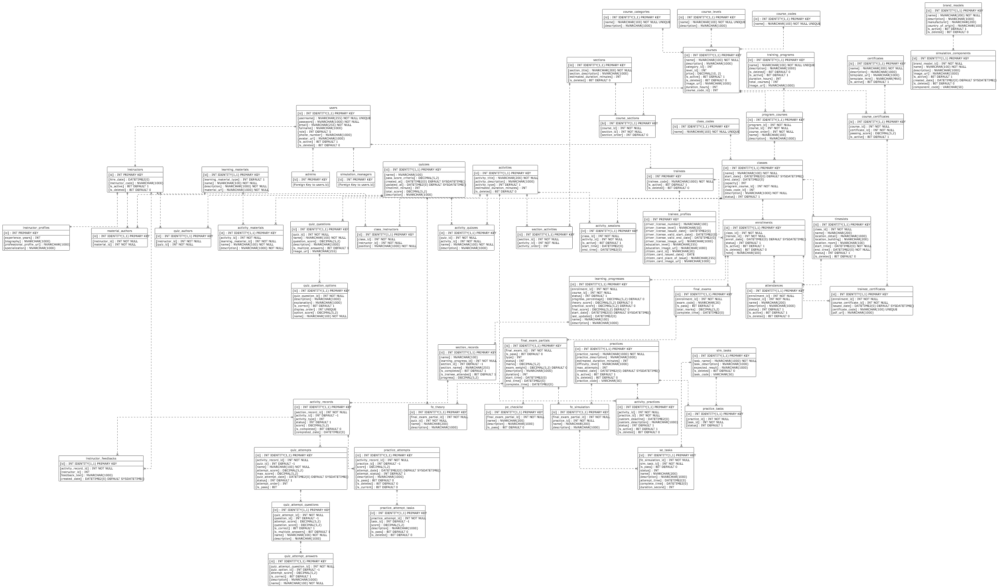

**Table Descriptions**

|  |  |  |
| --- | --- | --- |
| **No** | **Table** | **Description** |
| 1 | users | Stores the core account information for all system users including login credentials and contact info.  - Primary keys: id  - Foreign keys: None |
| 2 | admins | Stores specific information for users with the Admin role, linked to the main user record.  - Primary keys: id  - Foreign keys: id |
| 3 | simulation\_managers | Stores specific information for Simulation Managers, linked to the main user record.  - Primary keys: id  - Foreign keys: id |
| 4 | instructors | Stores specific information for Instructors, including employment details.  - Primary keys: id  - Foreign keys: id |
| 5 | trainees | Stores specific information for Trainees/Learners.  - Primary keys: id  - Foreign keys: id |
| 6 | instructor\_profiles | Contains detailed profile information for instructors such as experience and biography.  - Primary keys: id  - Foreign keys: id |
| 7 | trainee\_profiles | Contains detailed profile information for trainees, including driver license and citizen card details.  - Primary keys: id  - Foreign keys: id |
| 8 | course\_categories | Lookup table for defining different categories of courses.  - Primary keys: id  - Foreign keys: None |
| 9 | course\_levels | Lookup table for defining the difficulty or progression levels of courses.  - Primary keys: id  - Foreign keys: None |
| 10 | course\_codes | Lookup table for standardized course codes. - Primary keys: id - Foreign keys: None |
| 11 | courses | Stores the main course definitions including metadata like price and duration. - Primary keys: id  - Foreign keys: category\_id, level\_id, course\_code\_id |
| 12 | training\_programs | Defines high-level training programs that aggregate multiple courses.  - Primary keys: id  - Foreign keys: None |
| 13 | program\_courses | Junction table linking Courses to Training Programs, defining the order of courses within a program.  - Primary keys: id  - Foreign keys: program\_id, course\_id |
| 14 | sections | Defines content sections that organize activities within a course.  - Primary keys: Id  - Foreign keys: None |
| 15 | course\_sections | Junction table mapping sections to courses and defining their sequence.  - Primary keys: Id  - Foreign keys: course\_id, section\_id |
| 16 | activities | Stores individual learning activities (e.g., lessons, quizzes) that belong to sections. - Primary keys: id - Foreign keys: None |
| 17 | learning\_materials | Stores information about study materials like documents or videos.  - Primary keys: id  - Foreign keys: None |
| 18 | material\_authors | Links learning materials to the instructors who authored them.  - Primary keys: id  - Foreign keys: instructor\_id, material\_id |
| 19 | section\_activities | Junction table mapping activities to specific sections and defining their order.  - Primary keys: id - Foreign keys: section\_id, activity\_id |
| 20 | activity\_materials | Links learning materials to specific activities.  - Primary keys: id  - Foreign keys: activity\_id, learning\_material\_id |
| 21 | quizzes | Defines quiz assessments including time limits and passing criteria.  - Primary keys: id  - Foreign keys: None |
| 22 | quiz\_authors | Links quizzes to the instructors who created them.  - Primary keys: id  - Foreign keys: instructor\_id, quiz\_id |
| 23 | quiz\_questions | Stores questions belonging to a specific quiz.  - Primary keys: id  - Foreign keys: quiz\_id |
| 24 | quiz\_question\_options | Stores the possible answer options for a quiz question.  - Primary keys: id  - Foreign keys: quiz\_question\_id |
| 25 | activity\_quizzes | Junction table linking a Quiz to an Activity entity.  - Primary keys: id  - Foreign keys: quiz\_id, activity\_id |
| 26 | practices | Defines practical training exercises or simulation scenarios.  - Primary keys: id  - Foreign keys: None |
| 27 | sim\_tasks | Defines specific tasks or steps required within a simulation.  - Primary keys: id  - Foreign keys: None |
| 28 | practice\_tasks | Junction table linking simulation tasks to a practice scenario.  - Primary keys: id  - Foreign keys: practice\_id, task\_id |
| 29 | activity\_practices | Junction table linking a Practice to an Activity entity.  - Primary keys: id  - Foreign keys: activity\_id, practice\_id |
| 30 | brand\_models | Specific brand models of equipment (cranes) used in simulations.  - Primary keys: id  - Foreign keys: None |
| 31 | simulation\_components | Stores detailed components associated with specific brand models.  - Primary keys: id  - Foreign keys: brand\_model\_id |
| 32 | class\_codes | Lookup table for standardized class codes.  - Primary keys: id  - Foreign keys: None |
| 33 | classes | Represents a scheduled instance of a course (program course) with start/end dates.  - Primary keys: id  - Foreign keys: program\_course\_id, class\_code\_id |
| 34 | class\_instructors | Assigns instructors to specific classes with a designated position.  - Primary keys: id  - Foreign keys: class\_id, instructor\_id |
| 35 | enrollments | Records the registration of a trainee in a specific class.  - Primary keys: id  - Foreign keys: class\_id, trainee\_id |
| 36 | timeslots | Defines specific scheduling slots (date/time/location) for a class.  - Primary keys: id  - Foreign keys: class\_id |
| 37 | attendances | Tracks trainee attendance for specific timeslots.  - Primary keys: id  - Foreign keys: enrollment\_id, timeslot\_id |
| 38 | activity\_sessions | Schedules specific activities within a class timeframe.  - Primary keys: id  - Foreign keys: class\_id, activity\_id |
| 39 | final\_exams | Stores the overall record of a final exam for an enrollment.  - Primary keys: id  - Foreign keys: enrollment\_id |
| 40 | final\_exam\_partials | Stores specific parts (theory/practical) of a final exam.  - Primary keys: id  - Foreign keys: final\_exam\_id |
| 41 | pe\_checklist | Stores checklist items for grading practical final exams.  - Primary keys: id  - Foreign keys: final\_exam\_partial\_id |
| 42 | fe\_theory | Links a final exam partial to a specific theory quiz.  - Primary keys: id  - Foreign keys: final\_exam\_partial\_id, quiz\_id |
| 43 | fe\_simulation | Links a final exam partial to a specific simulation practice.  - Primary keys: id  - Foreign keys: final\_exam\_partial\_id, practice\_id |
| 44 | se\_tasks | Tracks the result of specific tasks within a simulation final exam.  - Primary keys: id  - Foreign keys: fe\_simulation\_id, sim\_task\_id |
| 45 | certificates | Defines certificate templates available in the system.  - Primary keys: id  - Foreign keys: None |
| 46 | course\_certificates | Links certificates to courses, defining passing requirements.  - Primary keys: id  - Foreign keys: course\_id, certificate\_id |
| 47 | trainee\_certificates | Records certificates issued to trainees upon course completion.  - Primary keys: id  - Foreign keys: enrollment\_id, course\_certificate\_id |
| 48 | learning\_progresses | Tracks the overall progress of a trainee within an enrollment.  - Primary keys: id  - Foreign keys: enrollment\_id |
| 49 | section\_records | Tracks a trainee's completion status for specific course sections.  - Primary keys: id  - Foreign keys: learning\_progress\_id |
| 50 | activity\_records | Tracks the detailed status and score of a trainee for specific activities.  - Primary keys: id  - Foreign keys: section\_record\_id |
| 51 | instructor\_feedbacks | Stores feedback provided by instructors on specific activity records.  - Primary keys: id  - Foreign keys: activity\_record\_id, instructor\_id |
| 52 | practice\_attempts | Records a specific attempt by a trainee to complete a practice activity.  - Primary keys: id  - Foreign keys: activity\_record\_id |
| 53 | practice\_attempt\_tasks | Records the result of individual tasks within a practice attempt.  - Primary keys: id  - Foreign keys: practice\_attempt\_id |
| 54 | quiz\_attempts | Records a specific attempt by a trainee to complete a quiz.  - Primary keys: id  - Foreign keys: activity\_record\_id |
| 55 | quiz\_attempt\_questions | Records the trainee's answer/score for a specific question in a quiz attempt.  - Primary keys: id  - Foreign keys: quiz\_attempt\_id |
| 56 | quiz\_attempt\_answers | Records the specific option selected by a trainee for a question.  - Primary keys: id  - Foreign keys: quiz\_attempt\_question\_id |

## 3. Detailed Design

### 3.1 Program & Course Management

#### 3.1.1 Class Diagram

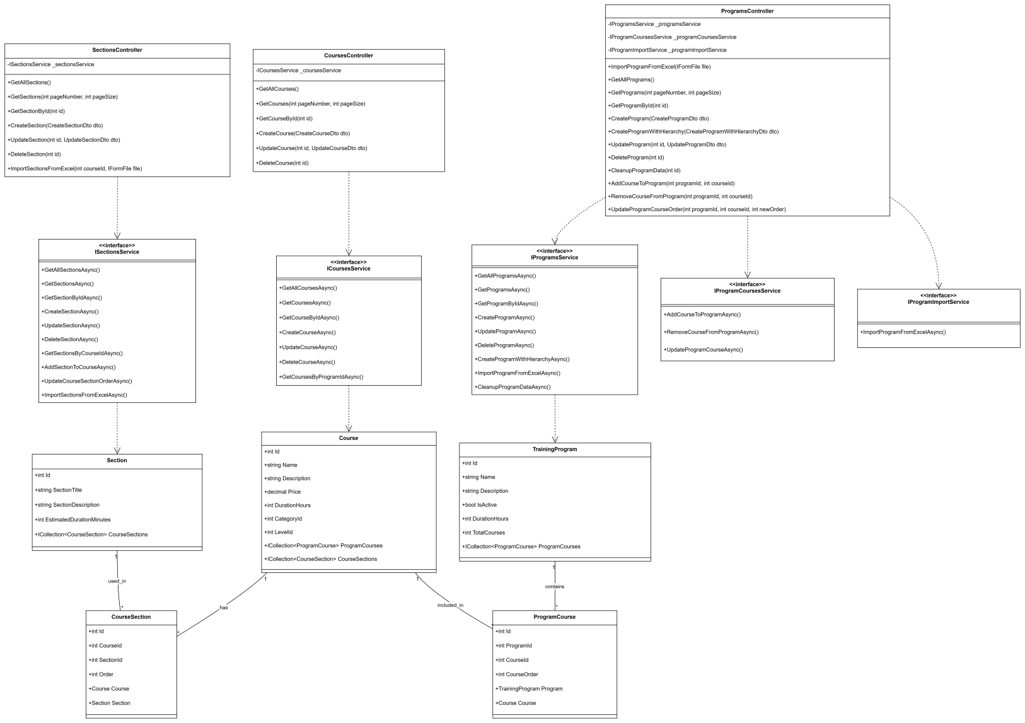

#### 3.1.2 Sequence Diagram - Admin Creates Program

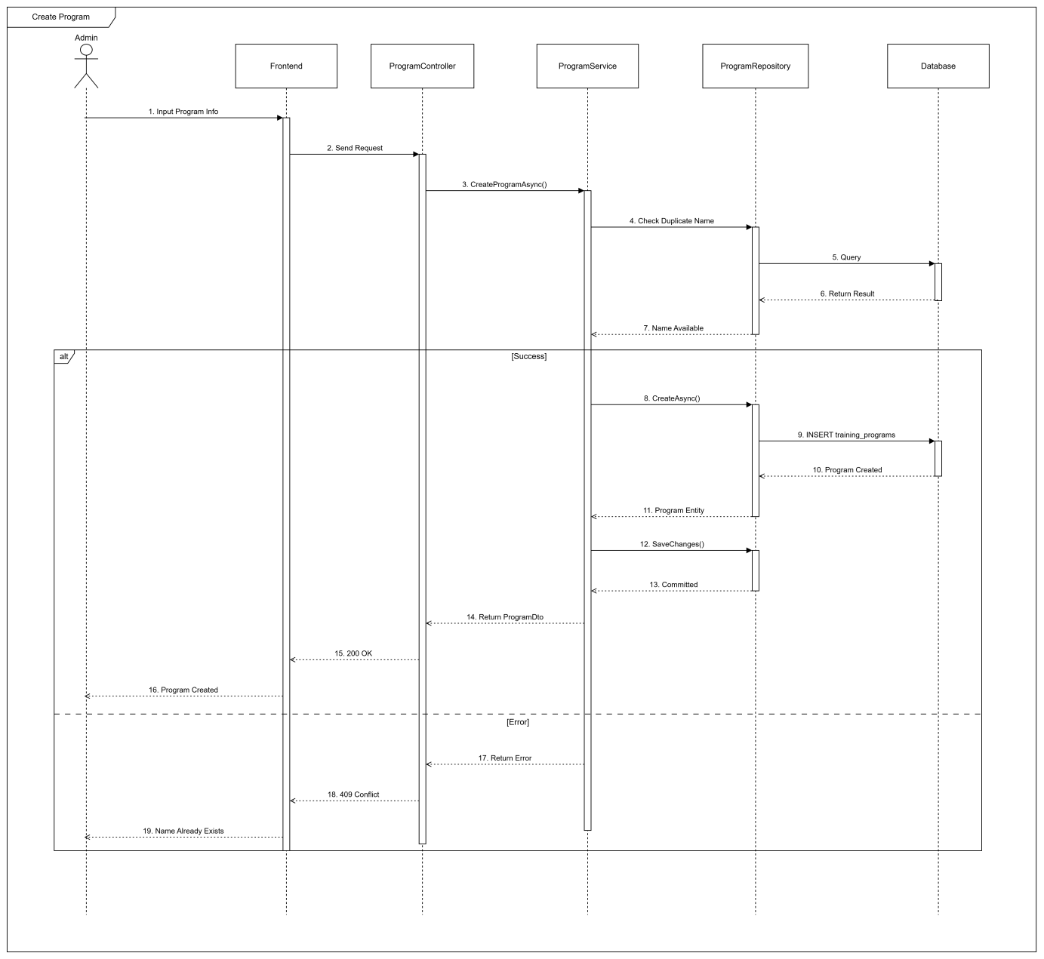

#### 3.1.3 Sequence Diagram - Admin Creates Course

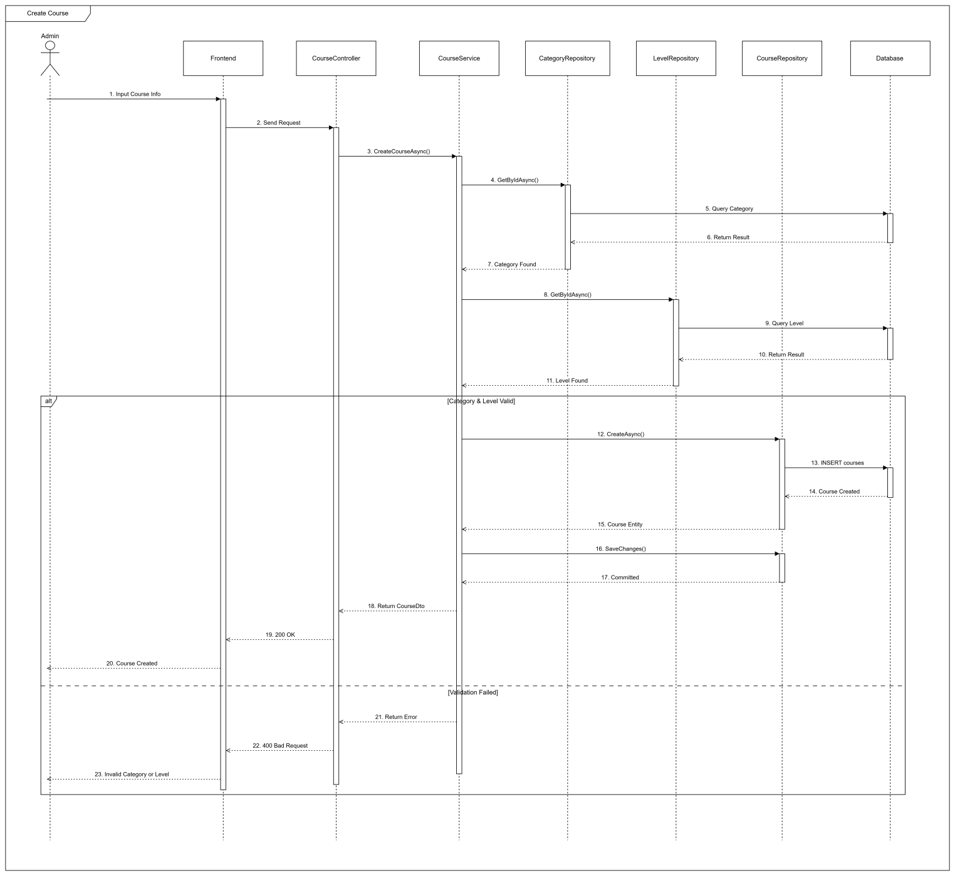

#### 3.1.4 Sequence Diagram - Admin Adds Course To Program

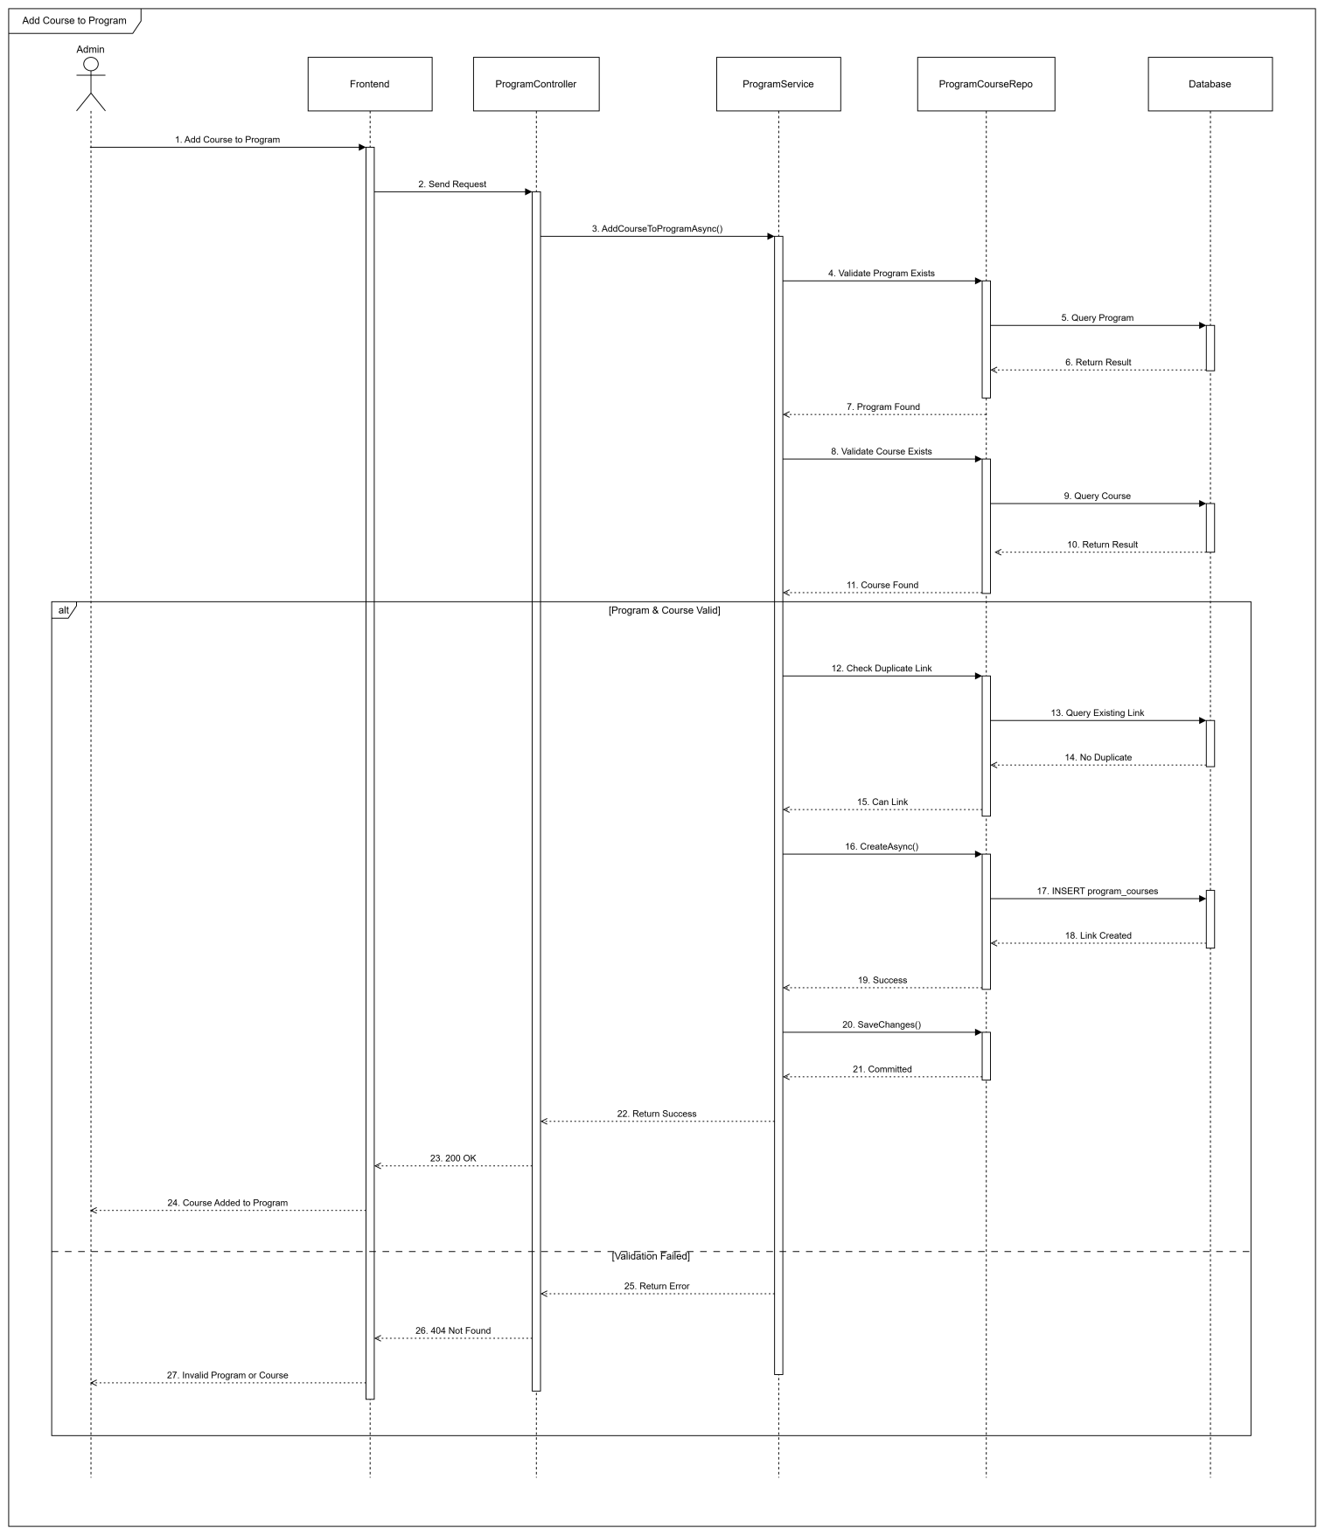

### 3.2 Class Management & Enrollment

#### 3.2.1 Class Diagram

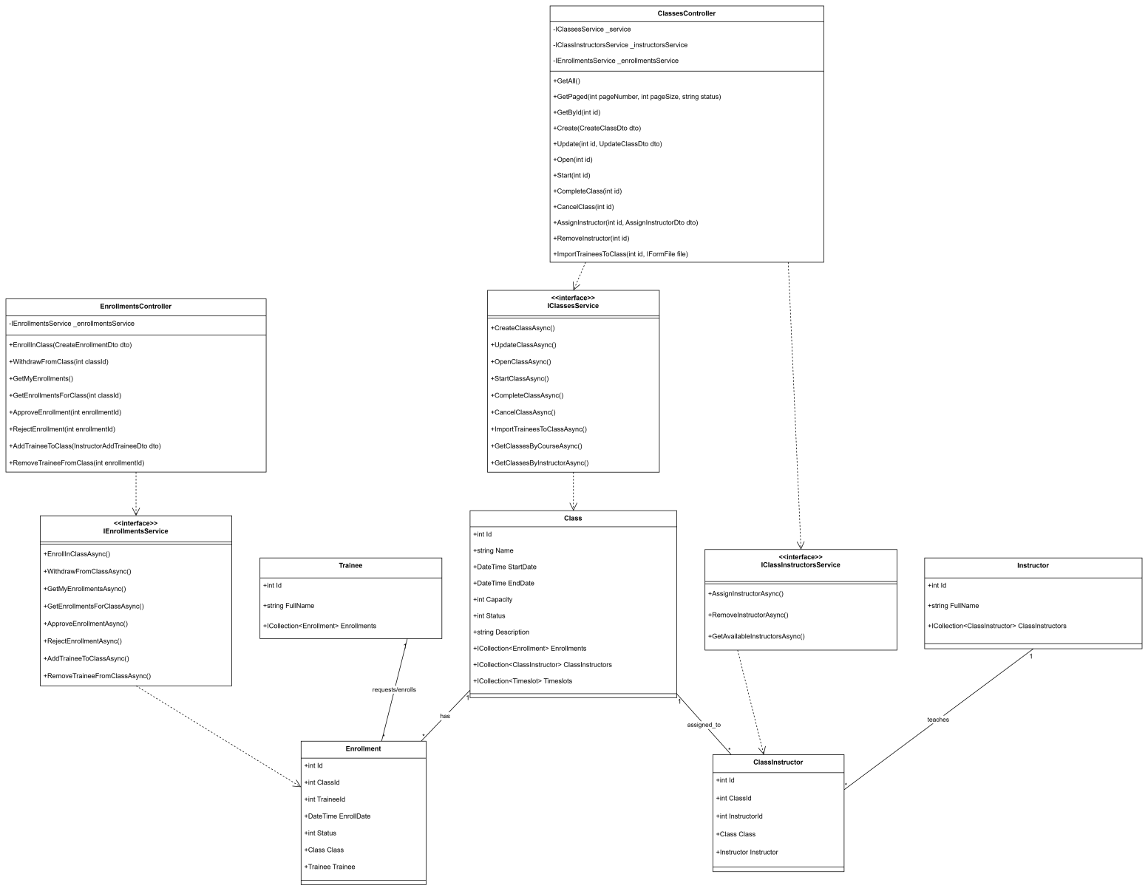

#### 3.2.2 Sequence Diagram - Trainee Enrolls to Class

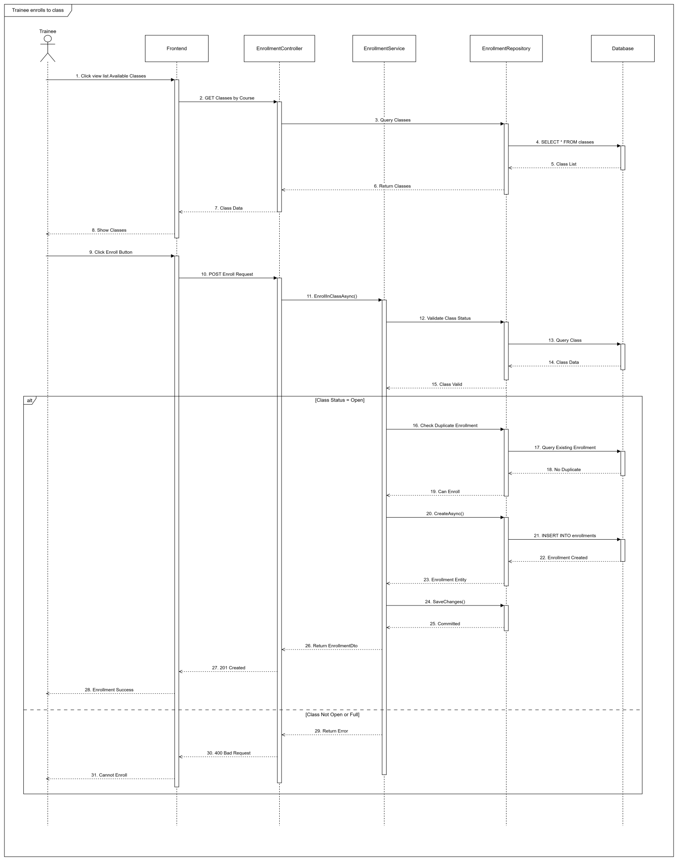

#### 3.2.3 Sequence Diagram - Admin Confirms Enrollment

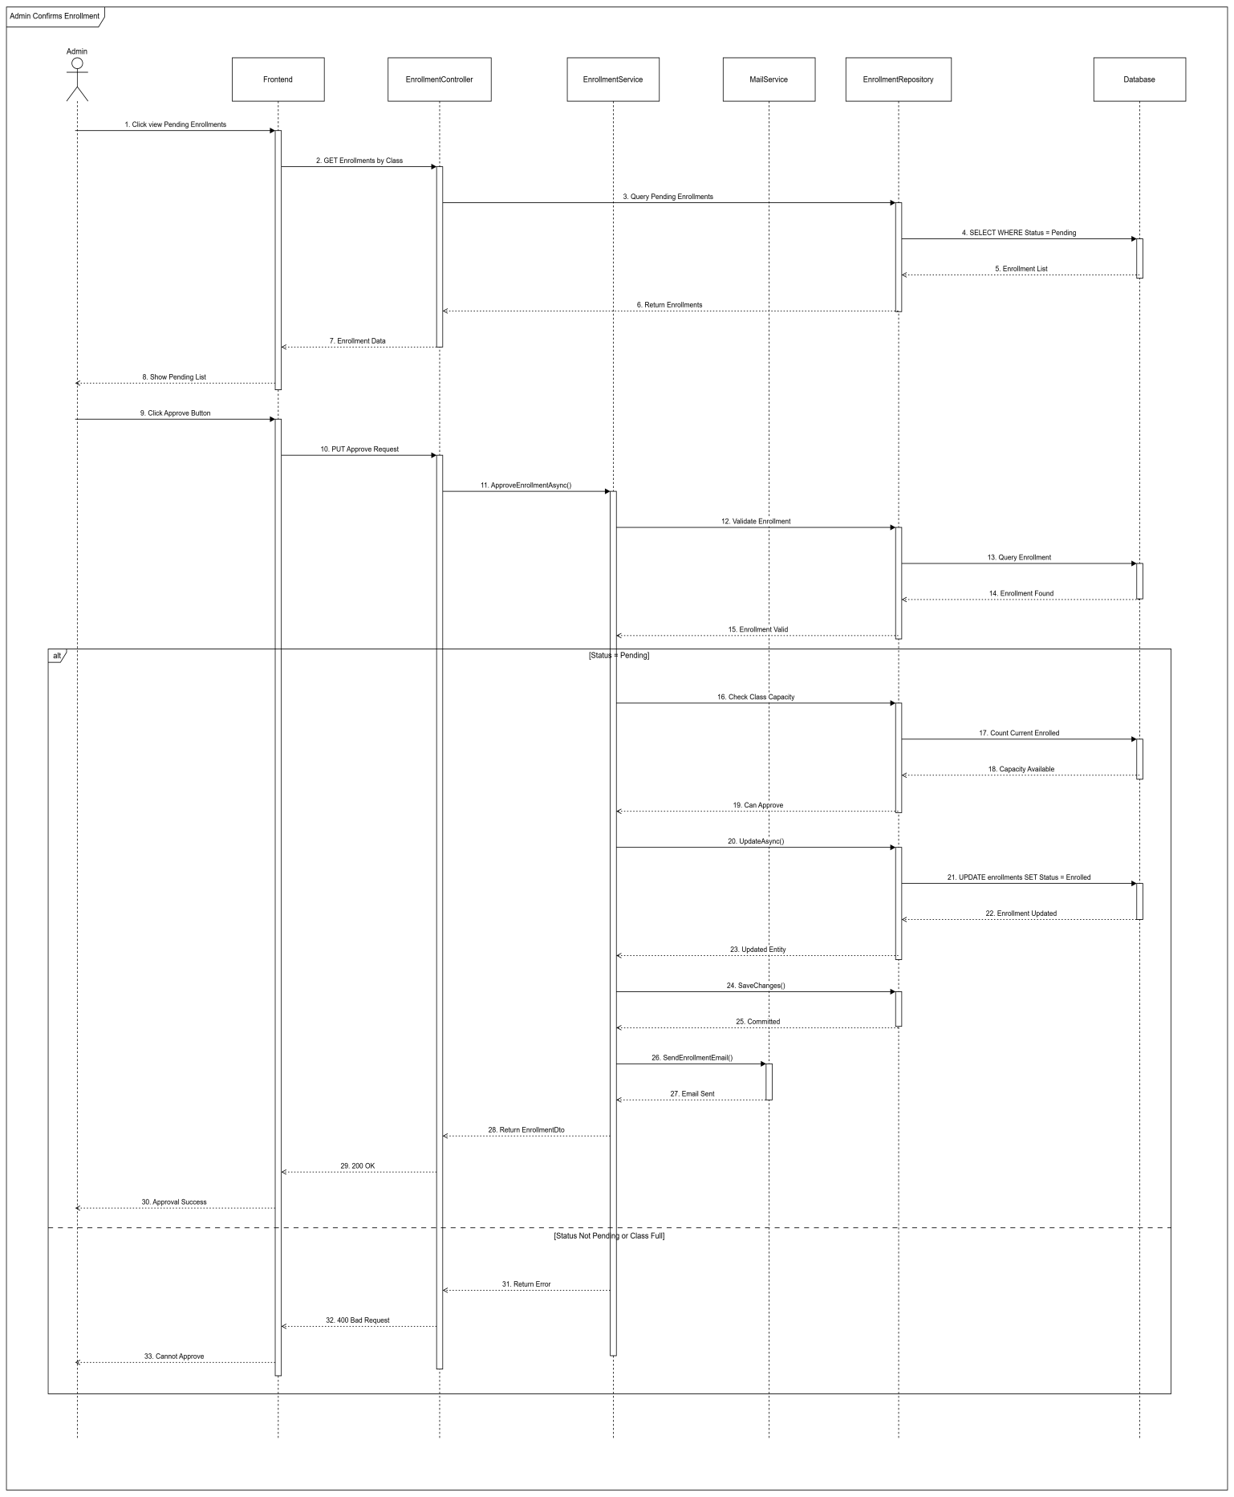

### 3.3 Simulation Practice Management

#### 3.3.1 Class Diagram

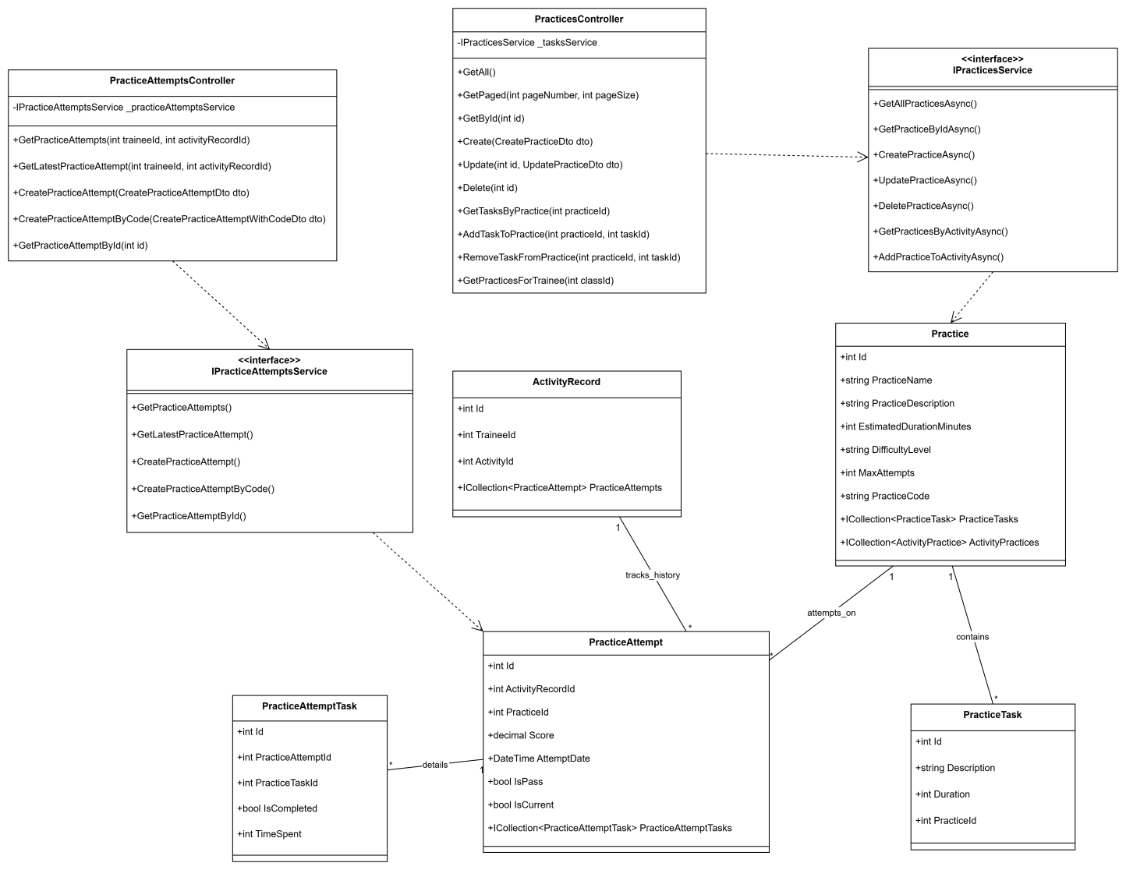

#### 3.3.2 Sequence Diagram - Simulation Manager Creates Practice

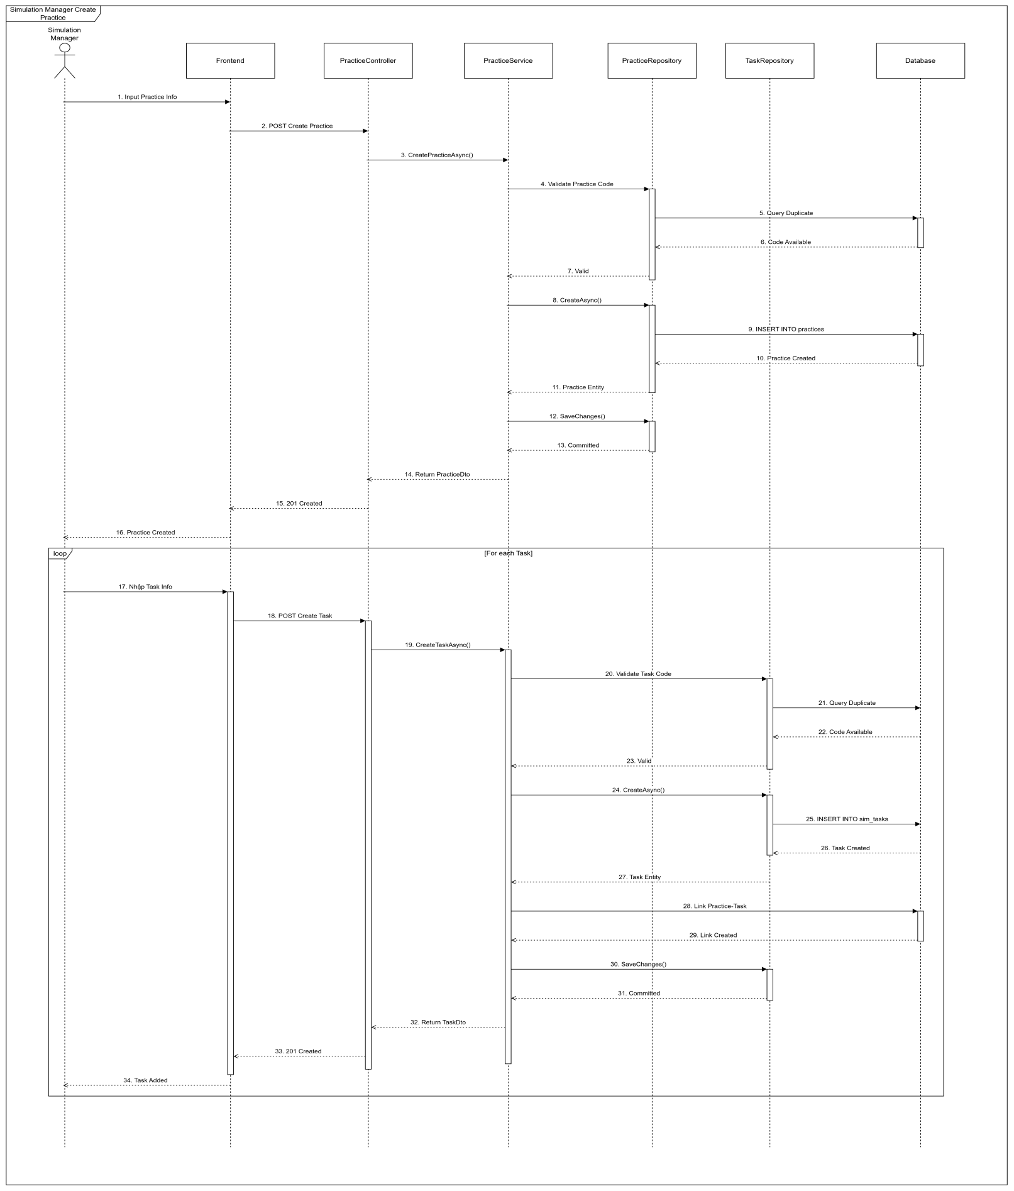

#### 3.3.3 Sequence Diagram - Trainees Attempt Practice

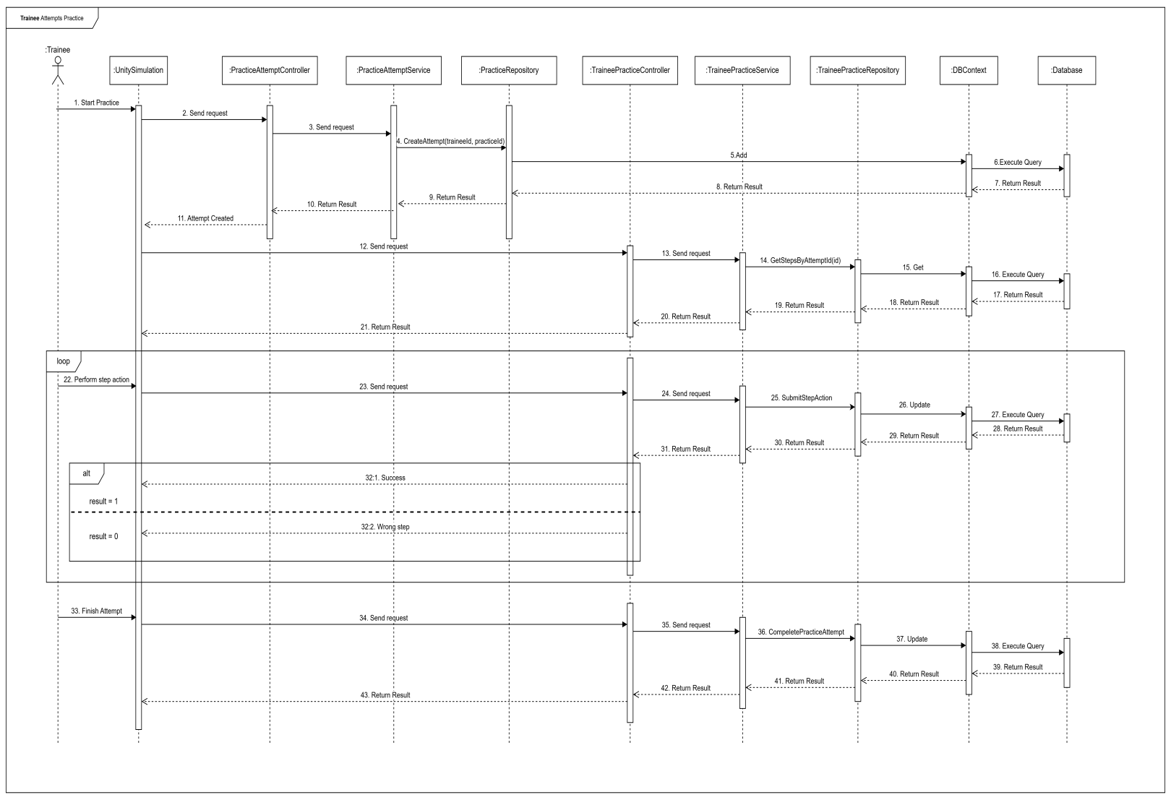

### 3.4 Final Exam Management

#### 3.4.1 Class Diagram

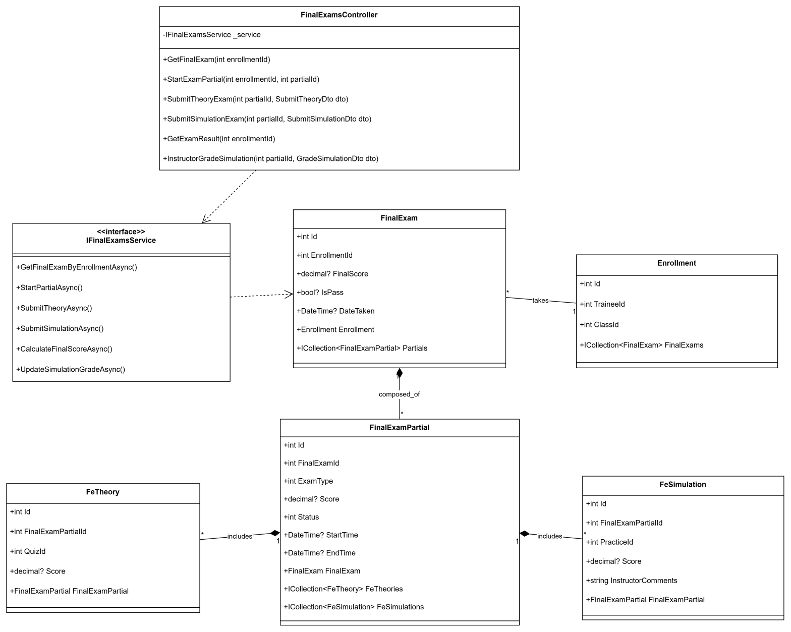

#### 3.4.2 Sequence Diagram - Instructor Configs Final Exam

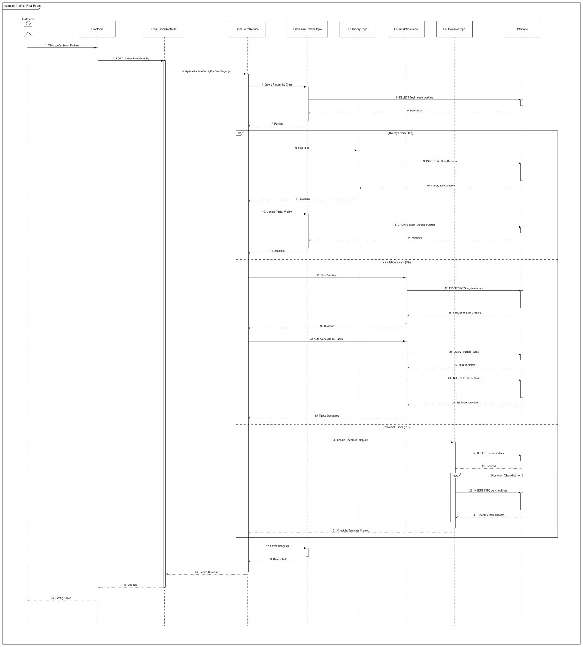

### 3.5 Dashboard & Reports

#### 3.5.1 Class Diagram

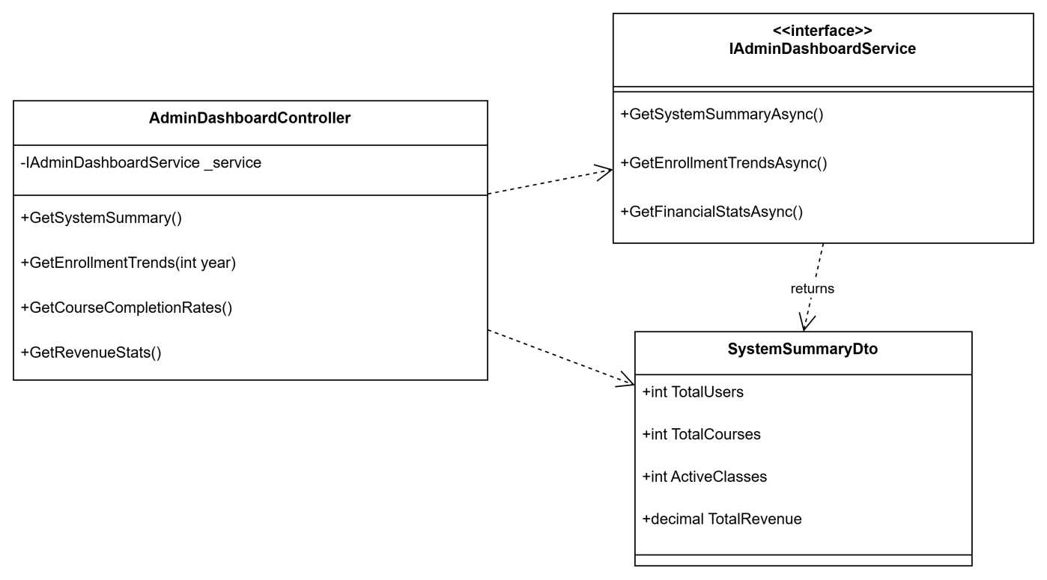

#### 3.5.2 Sequence Diagram - Admin Views Dashboard

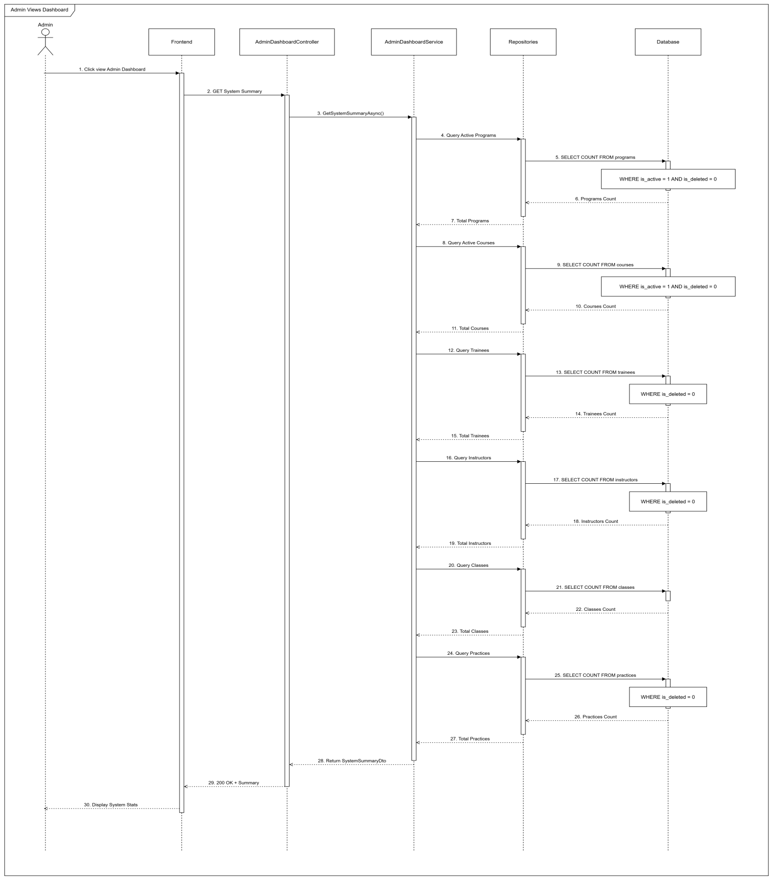

# V. Software Testing Documentation

## 1. Overall Description

### 1.1 Test Model

The project follows the Agile Testing Model. Testing is performed continuously alongside development sprints (Sprint 1 to Sprint 4).

* Requirement Analysis: Analyze SRS to identify test scenarios.
* Test Design: Create Test Cases (Excel).
* Test Execution: Execute Functional and Integration tests.
* Defect Tracking: Log issues on GitHub and re-test after fixing.

### 1.2 Testing Levels

* **Unit Testing:** Performed by Developers using xUnit (BE) and localized component testing (FE).
* **Integration Testing:** Verifying communication between React FE, .NET API, and the Simulation Client.
* **System Testing:** End-to-end testing of full workflows (e.g., Enrollment -> Learning -> Exam -> Certificate).
* **Acceptance Testing (UAT):** Validating the system against user requirements (Admin, Instructor, Trainee flows).

### 1.3 Testing Types

* **Functional Testing:** Verifying all features against SRS (CRUD, Workflows).
* **UI/UX Testing:** Ensuring responsiveness and usability (React components).
* **API Testing:** Validating data integrity using Postman.
* **Security Testing:** Verifying Role-based Access Control (RBAC) and JWT Authentication.

## 2. Test Plan

### 2.1 Test Stages

|  |  |  |  |  |
| --- | --- | --- | --- | --- |
| **Type of Test** | **Stage of Test** | | | |
| ***Unit*** | ***Integration*** | ***System*** | ***Acceptance*** |
| Function Test | X | X | X | X |
| User Interface Test |  |  | X | X |
| Performance Tests |  | X | X |  |
| Security Test |  | X | X |  |
| Data Integrity Test | X | X | X |  |

### 2.2 Resources

a. Human Resources (Refer to Team Involvements table in Section I.2)

b. Environment

|  |  |  |  |
| --- | --- | --- | --- |
| **Purpose** | **Tool** | **Provider** | **Version** |
| Backend Server | .NET 8 Web API | Microsoft | Hosted on Azure/Localhost |
| Frontend Client | ReactJS (Vite) | Open Source | Node.js v18+ |
| Database | SQL Server | Microsoft | Azure SQL / SQL Server 2019 |
| Simulation Client | Unity Build | Unity Tech | Windows Executable (.exe) |
| Browser | Google Chrome | Google | Latest Version |
| API Testing | Swagger / Swagger UI / Swagger Editor | OpenAPI Initiative | Latest Version |
| IDE | VS Code / Visual Studio | Microsoft | Code Editing |

### 2.3 Test Milestones

|  |  |  |  |
| --- | --- | --- | --- |
| **Milestone Task** | **Effort (md)** | **Start Date** | **End Date** |
| Test Planning | 2 | 10/11/2025 | 11/11/2025 |
| Test Case Design | 5 | 12/11/2025 | 18/11/2025 |
| Environment Setup | 1 | 19/11/2025 | 19/11/2025 |
| Test Execution (Round 1) | 5 | 20/11/2025 | 26/11/2025 |
| Bug Fixing & Retest | 3 | 27/11/2025 | 05/12/2025 |
| Final Report Generation | 1 | 06/12/2025 | 12/12/2025 |

### 2.4 Deliverables

|  |  |  |
| --- | --- | --- |
| **No** | **Deliverables** | **Due Date** |
| 1 | Report 5 - Test Documentation (This document) | 14/12/2025 |
| 2 | Report 5 - Test Cases (Excel File) | 14/12/2025 |
| 3 | Test Execution Reports (CSV/Excel) | 14/12/2025 |
| 4 | Bug Log / Defect List | 14/12/2025 |

## 3. Test Cases

Detailed test cases are provided in the attached file: Report5\_Test Report.xlsx. The test suite covers the following modules:

1. **Training Content & Curriculum Management:** Program, Course, Class, Section management.
2. **Trainee Enrollment & Learning Process:** Enrollment flow, "My Classes", learning materials.
3. **Simulation Integration:** Launching Sim client, syncing scores and results.
4. **Trainee Final Exam Module:** Theory and Simulation exams, grading logic.
5. **Dashboard Management:** Admin, Instructor, and Sim Manager analytics.

## 4. Test Reports

**Summary of Test Execution (Source: Test Statistics.csv):**

* **Total Test Cases:** 197
* **Passed:** 191
* **Failed:** 0
* **Pending/NA:** 6 (Skipped scenarios or future features)
* **Pass Rate:** ~96.95%

|  |  |  |  |  |  |  |
| --- | --- | --- | --- | --- | --- | --- |
| **No** | **Module Name** | **Passed** | **Failed** | **Pending** | **N/A** | **Total TCs** |
| *1* | *Training Content & Curriculum Management* | *50* | *0* | *0* | *0* | *56* |
| *2* | *Trainee Enrollment & Learning Process* | *73* | *0* | *0* | *0* | *73* |
| *3* | *Simulation Integration & Practice Session* | *9* | *0* | *0* | *0* | *9* |
| *4* | *Trainee Final Exam Module* | *36* | *0* | *0* | *0* | *36* |
| *5* | *Dashboard Management* | *23* | *0* | *0* | *0* | *23* |
| ***Total*** |  | ***191*** | ***0*** | ***0*** | ***0*** | ***197*** |

# VI. Release Package & User Guides

## 1. Deliverable Package

### 1.1 Source codes & documents

| **No.** | **Items** | **Sub-Items** | **Type** | **Version** |
| --- | --- | --- | --- | --- |
| **Code Package** | | | | |
| 1 | LSSCTC Backend API | Web Service | Modify | 10.5 |
| 2 | LSSCTC Frontend Web App | User Web Application | Modify | 9.3 |
| 3 | LSSCTC Simulator Desktop App | User Desktop Application | Modify | 3.0 |
| **Database** | | | | |
| 1 | Tables | lssctc\_db\_script.sql | Modify | N/A |
| **Documents** | | | | |
| 1 | Project  Introduction | Report1\_Project Introduction.docx | Modify | 1.0 |
| 2 | Project  Management  Plan | Report2\_Project Management Plan.docx | Modify | 1.0 |
| 3 | Software  Requirement  Specification | Report3\_Software Requirement Specification.docx | Modify | 1.0 |
| 4 | Software  Design  Document | Report4\_Software Design Document.docx | Modify | 1.0 |
| 5 | Test  Documentation | Report5\_Test Documentation.docx | Modify | 1.0 |
| 6 | Software User  Guides | Report6\_Software User Guides.docx | Modify | 1.0 |
| 7 | Final Project  Report | Report7\_FinalProjectReport.docx | Modify | 1.0 |

### 1.2 Known Issues, Limitations & Restrictions

* npm install fails: Delete the node\_modules folder and package-lock.json file, then run npm install again.
* Port 5173 already in use: Stop the process currently using the port or change the port number in the vite.config.js file.
* API calls fail with CORS error: Verify that the backend server is running and configured to accept requests from http://localhost:5173.
* Google OAuth not working: Ensure the Client ID in the .env file is correct and the Redirect URIs in the Google Cloud Console match your local URL.
* Blank page appears after loading: Open the browser developer tools console to check for JavaScript errors or missing environment variables.
* Module not found errors: Run npm install again to ensure all required dependencies are downloaded.

## 2. Installation Guides

### 2.1 System Requirements

#### 2.1.1 Hardware Requirements

|  |  |  |
| --- | --- | --- |
| **Component** | **Minimum** | **Recommended** |
| CPU | At least 2 GHz x64-bit CPU | Intel Core I5, 4GHz |
| Memory | At least 8GB RAM | 16GB RAM |
| Storage | 10GB SSD | 15GB SSD |
| Network | Internet Connection | 500 Mbps |

**Table 1: Hardware Requirements**

#### 2.1.2 Software Requirements

|  |  |  |
| --- | --- | --- |
| **Component** | **Software & Version** | **Description** |
| Operating System | Windows 10/11, macOS 10.15+, or Linux (Ubuntu 20.04+) | Operating system for running project |
| DBMS | SQL Server 2019 or Azure SQL Database | Database management system |
| Server Environment | .NET 8.0 SDK | Environment for running backend API |
| Frontend Environment | Node.js 18.17.0 or higher | Environment for running frontend application |
| Package Manager | NPM 9.x or higher | Package manager for frontend dependencies |
| IDE | Visual Studio Code 1.80+ or Visual Studio 2022 | Tool for viewing and editing code |
| VCS | Git 2.30+ | Tool for managing code version |
| Web Browser | Chrome 90+, Firefox 88+, Edge 90+, or Safari 14+ | Browser for accessing web application |
| Database Tool | SQL Server Management Studio (SSMS) 19+ or Azure Data Studio | Tool for database management |

**Table 2: Software Requirements**

### 2.2 Setup Files

#### 2.2.1 Database Files

* **lssctc\_db-script-v5.sql**: Complete database schema script for SQL Server
* **seed-data.sql**: Initial seed data for system (users, roles, course categories, etc.)

#### 2.2.2 Backend Files

* **lssctc-api. zip**: Complete backend API solution
  + Contains: Controllers, Services, Models, Repositories, and Configuration files
  + Main project: Lssctc.ProgramManagement
  + Shared library: Lssctc.Share

#### 2.2.3 Frontend Files

* **lssctc-web.zip**: Complete frontend web application
  + Contains: React components, Pages, Routes, Layouts, and Assets
  + Main entry: src/main.jsx
  + Configuration: vite.config.js, package.json

#### 2.2.4 Configuration Files

* **appsettings.json**: Backend API configuration (connection strings, JWT settings)
* **appsettings.Development.json**: Development-specific settings
* **.env. example**: Frontend environment variables template

### 2.3 Installation Instruction

#### 2.3.1 Setup Environment

**Step 1: Install Required Software**

* **Download and Install .NET 8.0 SDK**
  + Visit: <https://dotnet.microsoft.com/download/dotnet/8.0>
  + Download .NET 8.0 SDK for your operating system
  + Run installer and follow installation wizard
* **Download and Install Node.js 18.17.0 or higher**
  + Visit: <https://nodejs.org/>
  + Download LTS version (18.17.0 or newer)
  + Run installer and follow installation wizard
* **Download and Install SQL Server 2019**
  + Visit: <https://www.microsoft.com/en-us/sql-server/sql-server-downloads>
  + Download SQL Server 2019 Developer Edition (free)
  + Run installer and select:
    - Database Engine Services
    - SQL Server Replication
    - Client Tools Connectivity
  + Configure authentication mode: **Mixed Mode** (SQL Server and Windows Authentication)
  + Set SA password (remember this for connection string)
  + Verify installation using SQL Server Configuration Manager
* **Download and Install SQL Server Management Studio (SSMS)**
  + Visit: <https://docs.microsoft.com/en-us/sql/ssms/download-sql-server-management-studio-ssms>
  + Download latest version (19.x)
  + Run installer
  + Launch SSMS and connect to local SQL Server instance
* **Download and Install Visual Studio Code**
  + Visit: <https://code.visualstudio.com/>
  + Download for your operating system
  + Install recommended extensions:
    - C# Dev Kit
    - C# Extensions
    - JavaScript (ES6) code snippets
    - ESLint
    - Prettier - Code formatter
    - Thunder Client (for API testing)
* **Download and Install Git**
  + Visit: <https://git-scm.com/downloads>
  + Download for your operating system
  + Run installer with default options

**Step 2: Configure Git**

* Set your name and email
  + git config --global user.name "Your Name"
  + git config --global user.email "your. email@example.com"
* Verify configuration
  + git config --list

**Step 3: Connect Git with GitHub Account**

* Generate SSH key (if not already exists)
  + ssh-keygen -t ed25519 -C "your.email@example.com"
* Start SSH agent
  + eval "$(ssh-agent -s)"
* Add SSH key to agent
  + ssh-add ~/.ssh/id\_ed25519
* Copy public key to clipboard (Windows)
  + clip < ~/.ssh/id\_ed25519.pub
* Copy public key to clipboard (macOS)
  + pbcopy < ~/.ssh/id\_ed25519.pub
* Copy public key to clipboard (Linux)
  + cat ~/.ssh/id\_ed25519.pub | xclip -selection clipboard
* Go to GitHub → Settings → SSH and GPG keys → New SSH key
* Paste your public key and save

**Step 4: Clone Repositories**

* Create project directory
  + mkdir lssctc-project
  + cd lssctc-project
* Clone backend repository
  + git clone https://github.com/hieuvau198/lssctc-api.git
* Clone frontend repository
  + git clone https://github.com/hieuvau198/lssctc-web.git

#### 2.3.2 Setup Database

**Step 1: Create Database**

* Open **SQL Server Management Studio (SSMS)**
* Connect to your local SQL Server instance
* Right-click on **Databases** → Select **New Database**
* Database name: LSSCTC\_DB
* Click **OK**

**Step 2: Execute Database Script**

* Open **lssctc\_db-script-v5.sql** in SSMS
  + File → Open → File → Select lssctc\_db-script.sql
* Ensure **LSSCTC\_DB** is selected in database dropdown
* Click **Execute** button or press F5
* Wait for script execution to complete
* Verify tables are created:
* USE LSSCTC\_DB;
* GO
* SELECT TABLE\_SCHEMA, TABLE\_NAME
* FROM INFORMATION\_SCHEMA.TABLES
* WHERE TABLE\_TYPE = 'BASE TABLE'
* ORDER BY TABLE\_NAME;
* Expected output: 40+ tables including users, roles, courses, classes, quizzes, etc.

**Step 3: Execute Seed Data (Optional)**

* Open **seed-data.sql** in SSMS
* Execute script to populate initial data:
  + Default admin account
  + Course categories and levels
  + Course and class codes
  + Material types
* Verify seed data:
* SELECT \* FROM users;
* SELECT \* FROM course\_categories;
* SELECT \* FROM course\_levels;

**Step 4: Verify Database Connection String**

* Server name: localhost or (local) or .
* Database name: LSSCTC\_DB
* Authentication: SQL Server Authentication or Windows Authentication
* Example connection string:
* Server=localhost;Database=LSSCTC\_DB;User Id=sa;Password=YourPassword;TrustServerCertificate=True

#### 2.3.3 Setup and Run Backend API

**Step 1: Navigate to Backend Project**

* cd lssctc-project/lssctc-api/Lssctc/Lssctc.ProgramManagement

**Step 2: Configure Application Settings**

* Open **appsettings.json** in text editor or VS Code
* Update your custom value for: "ConnectionStrings", "JwtConfig", "EmailSettings"
* **Generate JWT Secret Key** (recommended):
  + Generate random 32-character key using PowerShell (Windows)
  + Generate random 32-character key using openssl (macOS/Linux)
* **Configure Email Settings** (for OTP functionality):
  + Use Gmail account
  + Enable 2-Factor Authentication
  + Generate App Password: <https://myaccount.google.com/apppasswords>
  + Use App Password in configuration (not your Gmail password)

**Step 3: Restore NuGet Packages**

* Restore all dependencies
  + dotnet restore

**Step 4: Build Project**

* Build project
  + dotnet build
  + Expected output: Build succeeded.

**Step 5: Run Backend API**

* Run in development mode
  + dotnet run

**Step 6: Verify API is Running**

* Open web browser
* Navigate to: **<http://localhost:5000/swagger>**
* You should see Swagger UI with all API endpoints

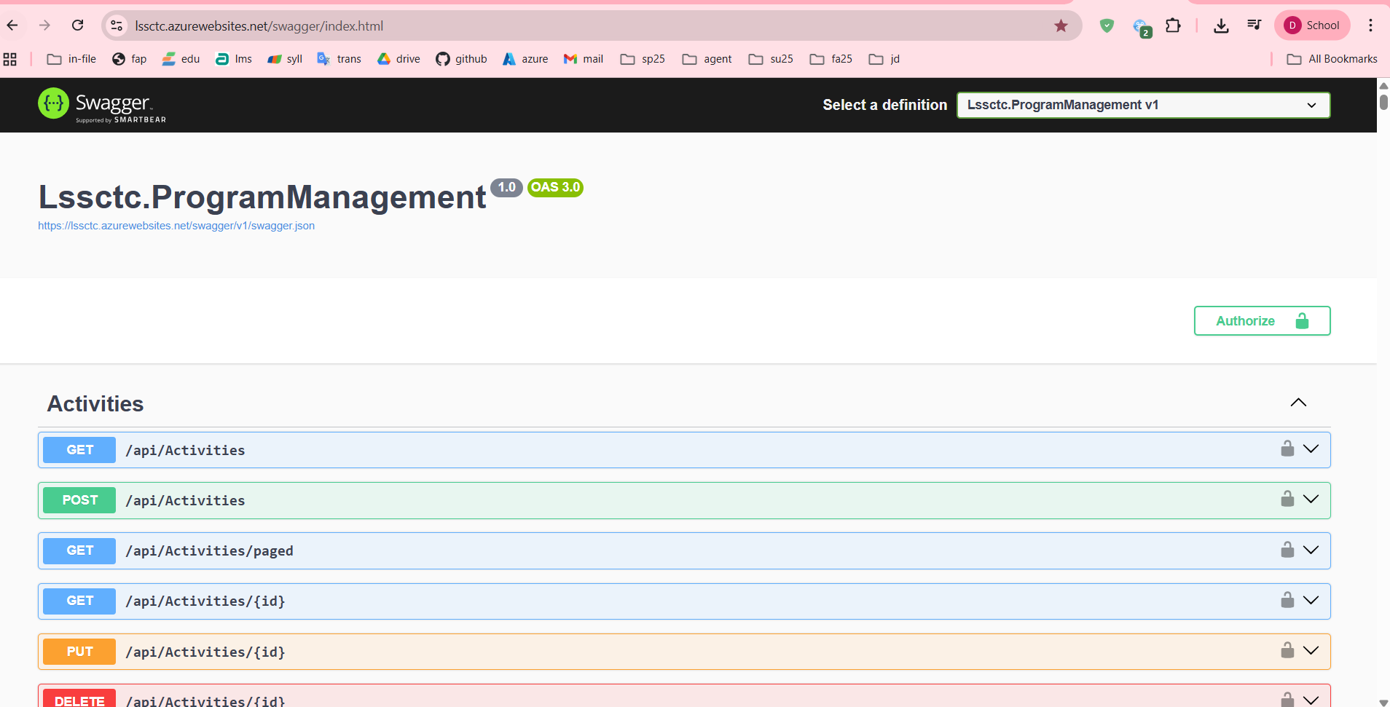

File: screenshot\_swagger\_ui\_homepage.png

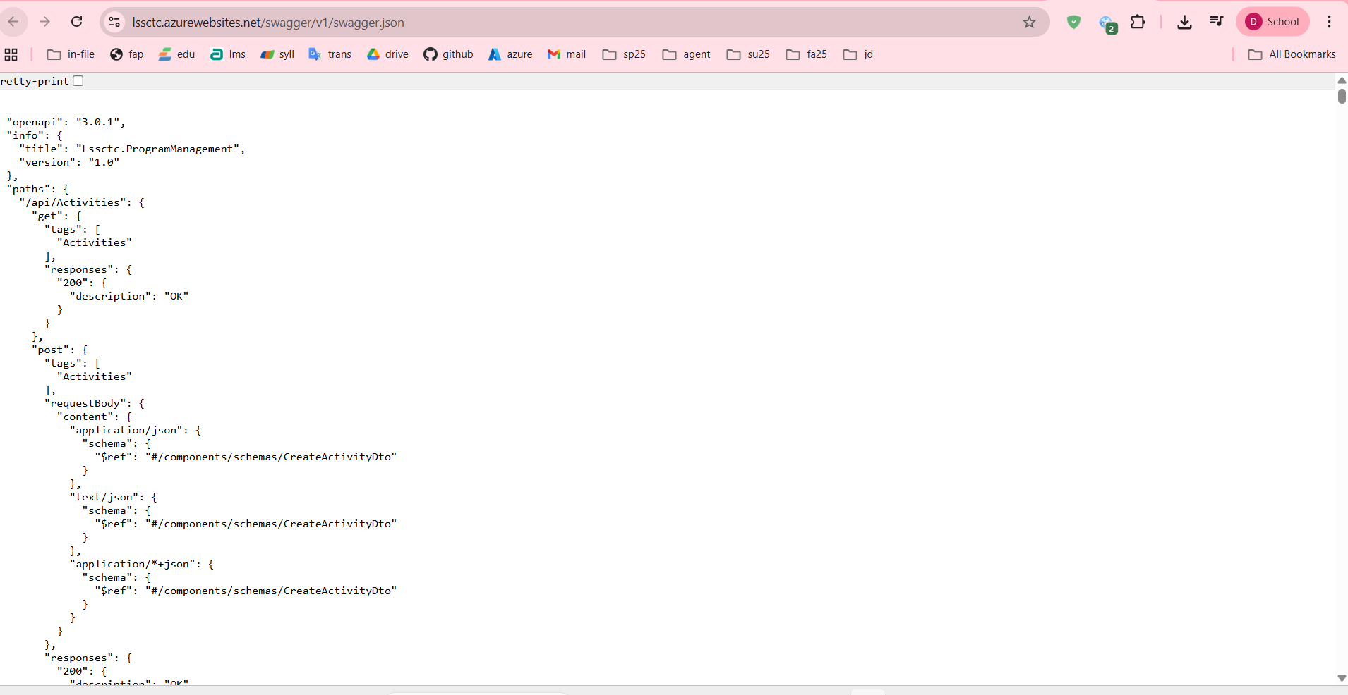

1. Test authentication endpoint:
   * Expand **POST /api/Authens/login-username**
   * Click **Try it out**
   * Enter test credentials (if seeded)
   * Click **Execute**
   * Verify 200 OK response with JWT token

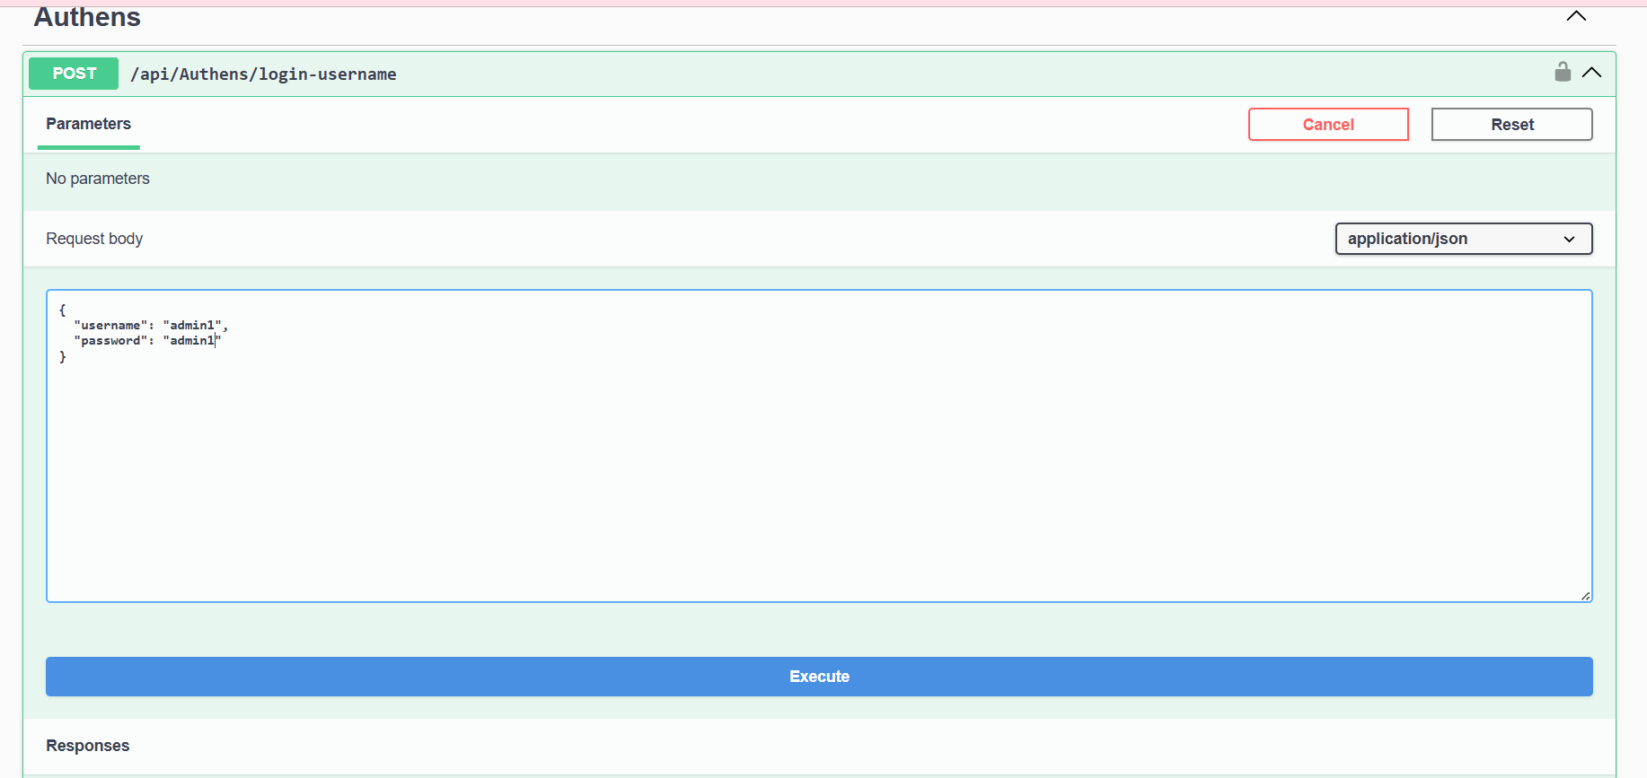

#### 2.3.4 Setup and Run Frontend Web Application

This section outlines how to configure, run, and verify the frontend client interface.

Step 1: Installation

* Navigate to the project directory and install the required dependencies.

Step 2: Environment Configuration

* Set up the connection to the backend and external services.
* Create the configuration file:
* Windows: copy .env.example .env
* macOS/Linux: cp .env.example .env
* Edit the .env file
* Optional: Google OAuth Setup To enable "Sign in with Google," create a project in the Google Cloud Console:
* Type: OAuth 2.0 Web Application
* Origin: http://localhost:5173
* RedirectURI: http://localhost:5173/auth/callback
* Action: Paste the generated Client ID into your .env file.

Step 5: Production Build (Optional)

* To prepare the application for final deployment:
* Build: Run npm run build to generate the dist/ folder.
* Preview: Run npm run preview to test the build at http://localhost:5173.

#### 2.3.5 Deployment to Production

**Backend Deployment Options:**

**Option 1: Deploy to Azure App Service**

1. Install Azure CLI
2. Login to Azure:
3. az login
4. Create App Service:
5. az webapp create --resource-group myResourceGroup --plan myAppServicePlan --name lssctc-api --runtime "DOTNET:8.0"
6. Deploy:
7. dotnet publish -c Release
8. az webapp deploy --resource-group myResourceGroup --name lssctc-api --src-path ./bin/Release/net8.0/publish. zip
9. Configure connection string in Azure Portal
10. Update JWT and Email settings

**Option 2: Deploy to Docker Container**

1. Create Dockerfile in backend project root:
2. FROM mcr.microsoft.com/dotnet/aspnet:8.0
3. WORKDIR /app
4. COPY ./publish .
5. ENTRYPOINT ["dotnet", "Lssctc.ProgramManagement.dll"]
6. Build and run:
7. dotnet publish -c Release -o ./publish
8. docker build -t lssctc-api .
9. docker run -p 5000:80 lssctc-api

**Frontend Deployment Options:**

**Option 1: Deploy to Vercel**

1. Install Vercel CLI:
2. npm install -g vercel
3. Login:
4. vercel login
5. Deploy:
6. vercel --prod
7. Configure environment variables in Vercel dashboard

**Option 2: Deploy to Azure Static Web Apps**

1. Build production bundle:
2. npm run build
3. Create Static Web App in Azure Portal
4. Connect to GitHub repository
5. Configure build settings:
   * App location: /
   * API location: (empty)
   * Output location: dist
6. Azure will automatically build and deploy on push

**Option 3: Deploy to Netlify**

1. Install Netlify CLI:
2. npm install -g netlify-cli
3. Build:
4. npm run build
5. Deploy:
6. netlify deploy --prod --dir=dist

**Database Deployment:**

**Deploy to Azure SQL Database**

1. Create Azure SQL Database in Azure Portal
2. Export local database using SSMS:
   * Right-click database → Tasks → Generate Scripts
   * Select all objects
   * Save script
3. Connect to Azure SQL Database
4. Execute script to create schema

Update connection string in backend configuration

## 3. User Manual

### 3.1 Terms and definitions

|  |  |
| --- | --- |
| **Term** | **Definition** |
| LSSCTC | Learner Management and 3D Simulation System for Crane Training Center |
| Admin | System administrator with full access to all features and user management |
| Instructor | Teacher/trainer who creates course content, quizzes, and evaluates trainees |
| Trainee | Student enrolled in crane operation training courses |
| Program Manager | Role responsible for curriculum design and course orchestration |
| Simulation Manager | Role responsible for managing 3D simulation components and scenarios |
| Training Program | Complete curriculum consisting of multiple courses leading to certification |
| Course | Individual training module covering specific crane operation topics |
| Section | Subdivision within a course containing organized activities |
| Activity | Learning task within a section (material, quiz, or practice) |
| Learning Material | Educational content (PDF, video, image, URL) provided to trainees |
| Quiz | Assessment containing multiple-choice or single-choice questions |
| Practice | Hands-on simulation task for skill development and evaluation |
| Class | Group of trainees enrolled in a program with scheduled sessions |
| Timeslot | Scheduled session for class instruction with date, time, and instructor |
| Enrollment | Trainee's registration and participation in a specific class |
| Activity Record | Trainee's progress and completion status for an activity |
| Quiz Attempt | Trainee's submission of a quiz with scored results |
| Practice Attempt | Trainee's completion of a practice session with performance metrics |
| Simulation Component | 3D model or asset used in crane operation simulation environment |
| Brand Model | Specific crane manufacturer and model configuration |
| JWT | JSON Web Token - authentication token for API access |
| OTP | One-Time Password - 6-digit code for password reset verification |
| WebGL | Web Graphics Library - browser technology for 3D rendering |

### 3.2 System requirements

For End Users (Trainees, Instructors):

* Operating System:
  + Windows 10/11 (64-bit)
  + macOS 10.15 (Catalina) or later
  + Linux (Ubuntu 20.04+ or equivalent)
* Web Browser:
  + Google Chrome 90+ (Recommended)
  + Mozilla Firefox 88+
  + Safari 14+ (macOS only)
  + Microsoft Edge 90+
* Internet Connection:
  + Minimum: 5 Mbps (for video streaming and general use)
  + Recommended: 10 Mbps (for 3D simulation)
* Display Resolution:
  + Minimum: 1366x768
  + Recommended: 1920x1080 or higher
* Input Devices:
  + Mouse and keyboard (required)
  + Trackpad supported but not recommended for simulation

For Simulation Features:

* RAM:
  + Minimum: 8GB
  + Recommended: 16GB
* Graphics Card:
  + Dedicated GPU with WebGL 2.0 support
  + NVIDIA GTX 1050 or equivalent
  + AMD Radeon RX 560 or equivalent
* Storage:
  + 2GB free space for cached 3D models and textures
* CPU:
  + Minimum: Intel Core i5 or AMD Ryzen 5
  + Recommended: Intel Core i7 or AMD Ryzen 7

For System Administrators:

* All of the above, plus:
* Access to SQL Server Management Studio or Azure Data Studio
* Network access to application server and database server

Remote desktop or SSH access to servers (for on-premise deployment)

### 3.3 Application Usage

#### a. Overview

The LSSCTC system is a web-based Learning Management System integrated with 3D crane operation simulation capabilities. It consists of:

1. Frontend (Web Application): React-based single-page application
2. Backend (API): .NET 8 RESTful API with JWT authentication
3. Database: SQL Server relational database
4. 3D Engine: WebGL-based simulation environment (planned)

#### b. Feature 1: Authentication & User Management

Purpose: Secure user authentication with multiple login methods and role-based access control

Available Functions:

1. Login with Username/Password
2. Login with Email/Password
3. Login with Google OAuth
4. Password Reset (OTP-based)
5. Logout

Profile View and Update

#### c. Feature 2: Admin - Course Management

Purpose: Create, organize, and manage training courses

Available Functions:

1. View All Courses (with pagination, search, sort)
2. Create New Course
3. Edit Course Details
4. Delete Course (soft delete)
5. Assign Course to Programs

View Course Enrollments

#### d. Feature 3: Admin - Class Management

Purpose: Organize trainees into classes, assign instructors, and manage schedules

Available Functions:

1. View All Classes
2. Create New Class
3. Edit Class Details
4. View Class Enrollments
5. Approve/Reject Enrollments
6. Manage Class Timeslots (Schedule)

Assign Instructors

#### e. Feature 4: Instructor - Quiz Management

Purpose: Create assessments to evaluate trainee knowledge and understanding

Available Functions:

1. Create Quiz with Questions
2. Import Quiz from Excel Template
3. Edit Quiz and Questions
4. Delete Quiz
5. Assign Quiz to Activity

View Quiz Attempts and Results

**Create Quiz*:***

Step-by-Step Instructions:

1. Login as Instructor
2. Navigate to Instructor Dashboard
3. Click "Quizzes" in sidebar

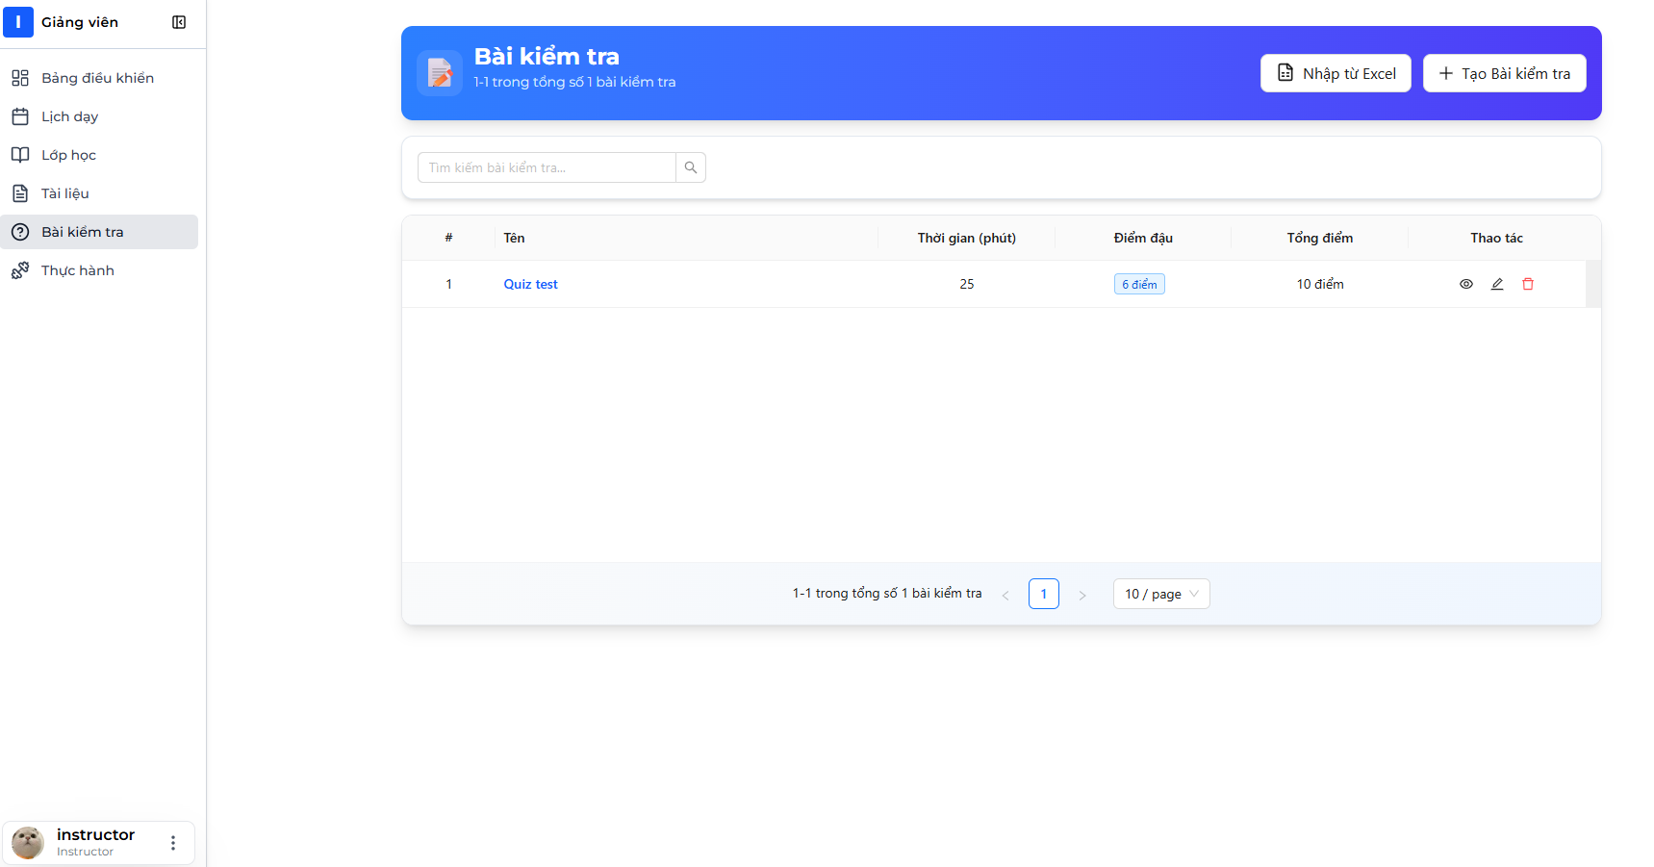

1. Quizzes list page displays showing your created quizzes



1. Click "Create New Quiz" button

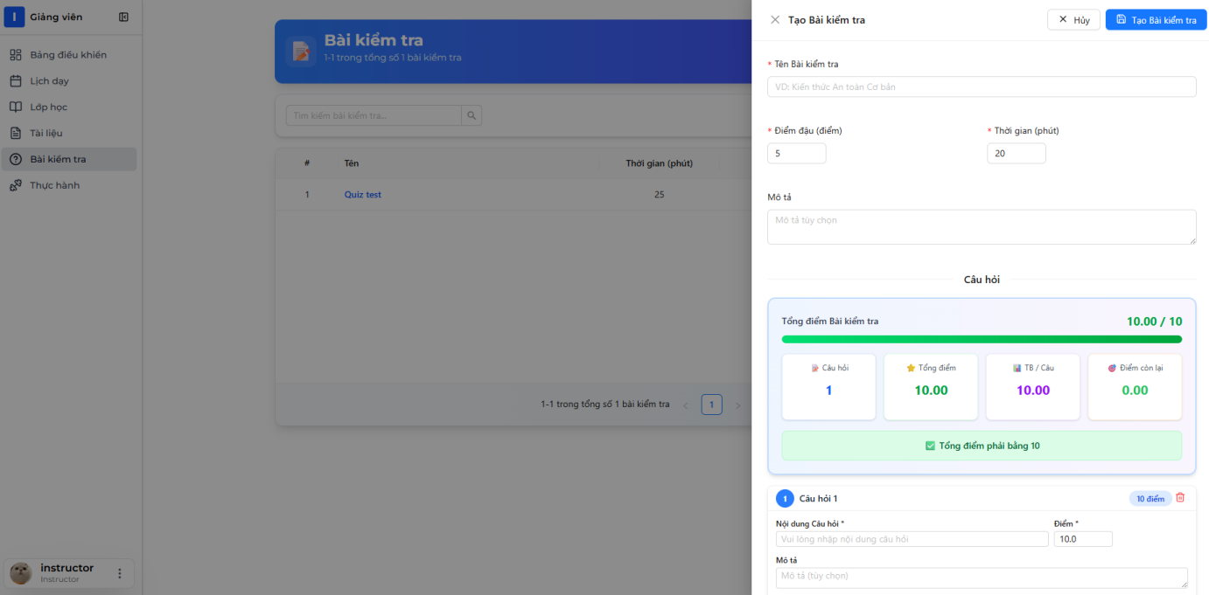

1. Quiz creation form opens (may be multi-step)

Step 1: Quiz Basic Information

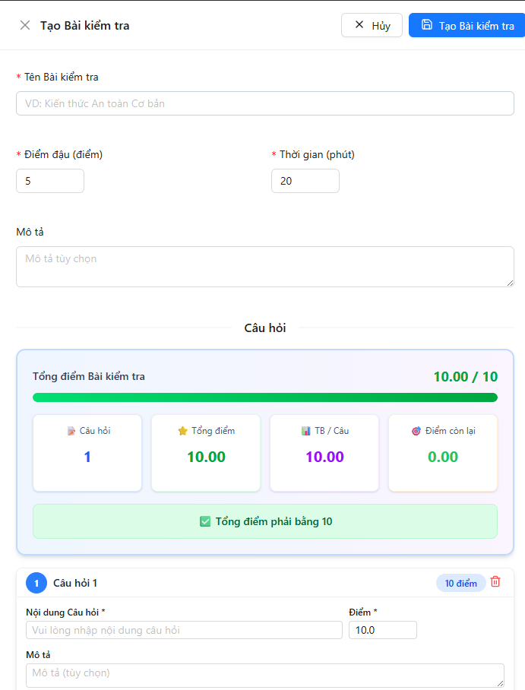

1. Fill in quiz information:
   * Quiz Name: "Mobile Crane Safety Assessment"
   * Description: "Test your knowledge of crane safety procedures"
   * Duration: 30 minutes
   * Passing Score: 7
2. Click "Next"

Step 2: Add Questions

📷 INSERT SCREENSHOT HERE: Add Questions Section

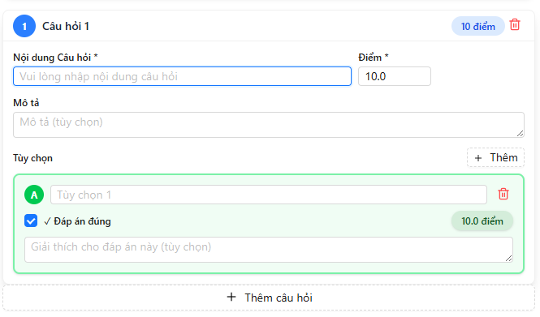

1. Click "Add Question" button
2. Question form appears



1. Fill in question details:
   * Question Text: "What is the safe minimum distance from a power line for crane operations?"
   * Score Points:10
   * Explanation: "Regulations often require at least 10 meters depending on voltage."
2. Add Options:
   * Click "Add Option" button for each option

📷 INSERT SCREENSHOT HERE: Add Option Interface

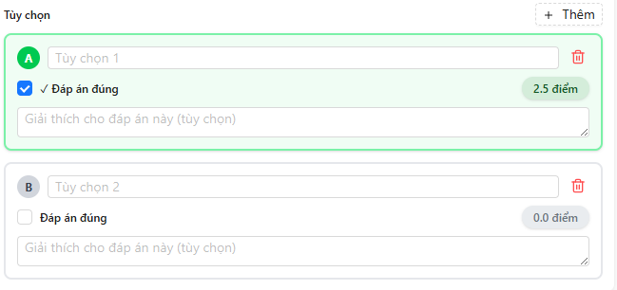

1. Enter options:
   * Option 1: "1 meter" (not correct)
   * Option 2: "3 meters" (not correct)
   * Option 3: "10 meters" (check "Is Correct")
   * Option 4: "50 meters" (not correct)

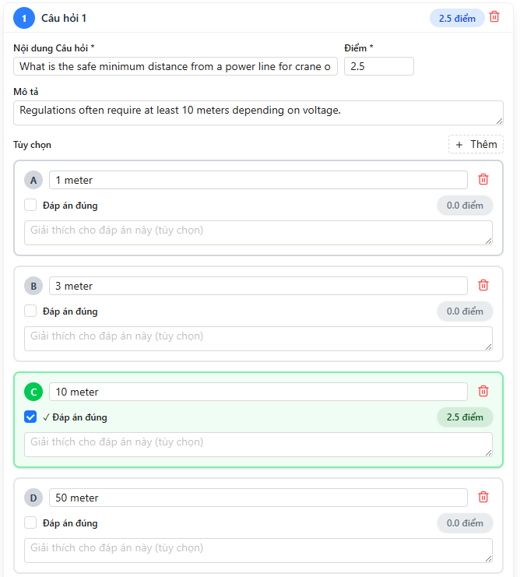

1. Click "Save Question"
2. Question is added to quiz questions list

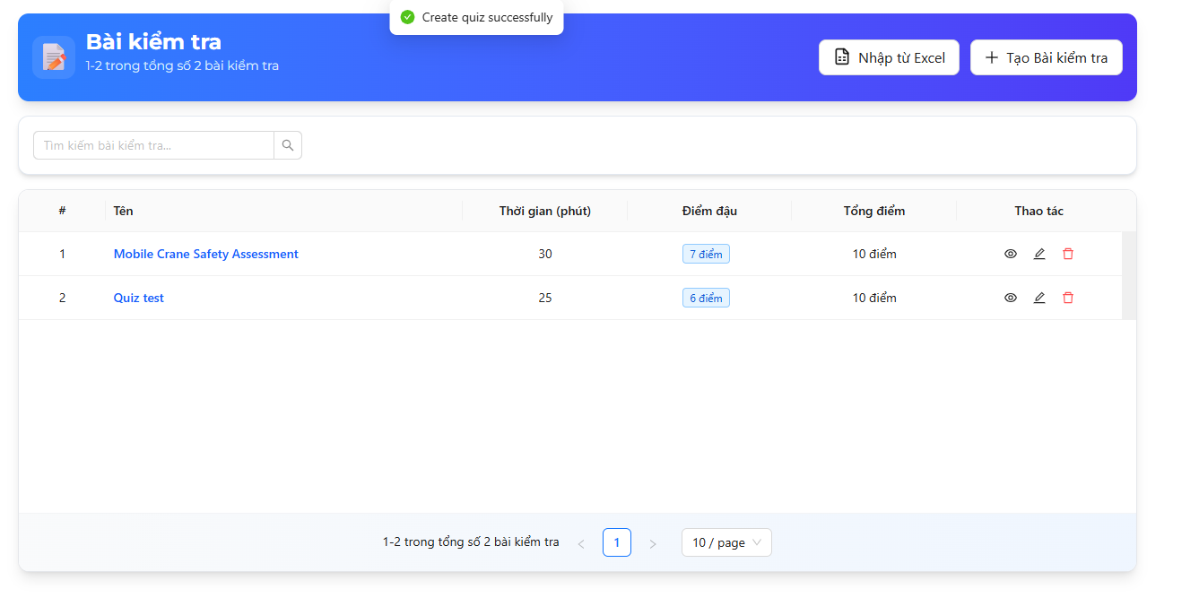

1. Repeat steps 9-15 to add more questions
   * Add at least 2-10 questions per quiz



1. Review Quiz:
   * Check all questions are added
   * Verify total points
   * Ensure at least one correct option per question
2. Click "Save Quiz" button
3. Success message: "Quiz created successfully"



API Endpoint Used:

POST /api/Quizzes/with-questions

Request Body:

{

"name": "Mobile Crane Safety Assessment",

"description": "Test your knowledge.. .",

"durationMinutes": 30,

"passingScore": 70,

"isRandomizeQuestions": true,

"isRandomizeOptions": true,

"showCorrectAnswers": true,

"isActive": true,

"questions": [

{

"questionText": "What is the safe minimum distance.. .",

"score": 2.5,

"isMultiple": false,

"explanation": "Regulations often require.. .",

"options": [

{ "optionText": "1 meter", "isCorrect": false },

{ "optionText": "3 meters", "isCorrect": false },

{ "optionText": "10 meters", "isCorrect": true },

{ "optionText": "50 meters", "isCorrect": false }

]

},

{ ... more questions... }

]

}

Response (200 OK):

{

"status": 200,

"message": "Create quiz successfully",

"data": { "quizId": 45 }

}

**Import Quiz*:***

Import Quiz from Excel

Step-by-Step Instructions:

1. Download Excel template first:
   * Navigate to Quizzes page
   * Click "Import Quiz" dropdown
   * Select "Download Template"

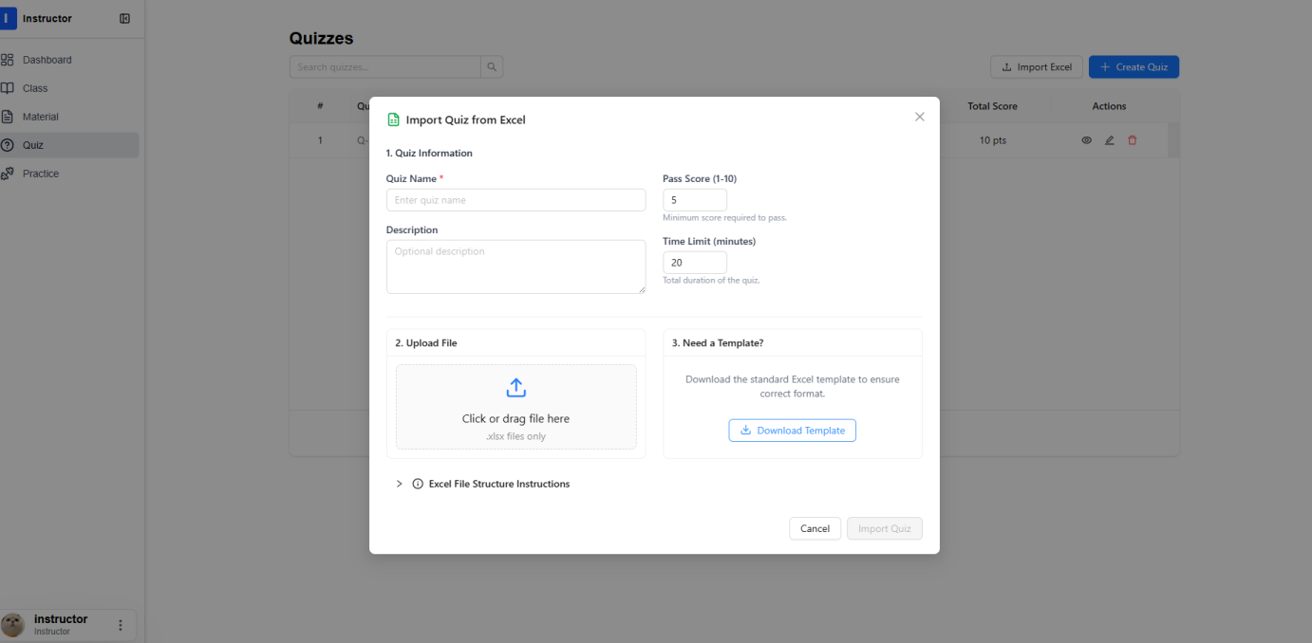

1. Template Excel file downloads

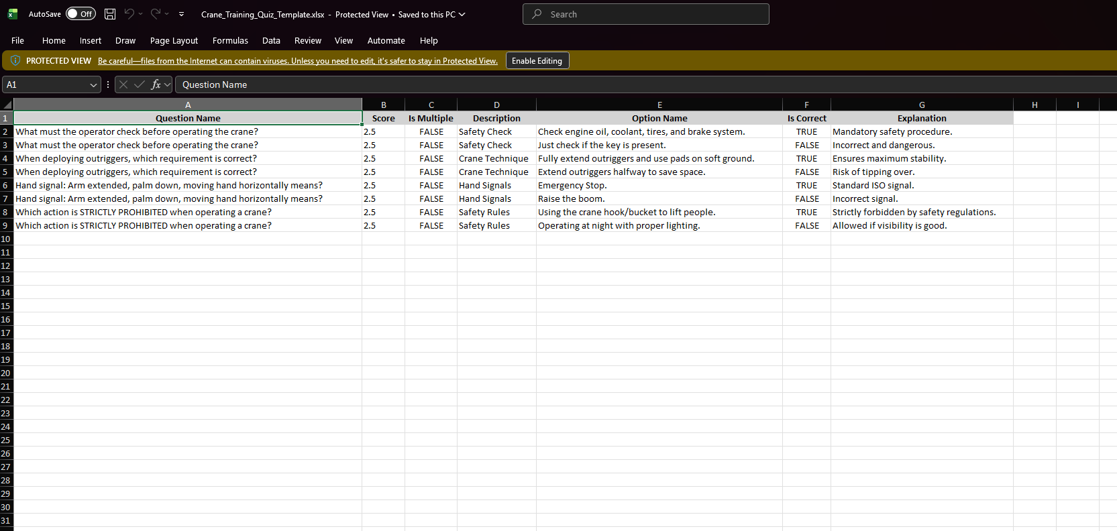

1. Fill in template:
   * Each question can have multiple rows (one per option)
   * Question Name must be same for all options of same question
   * Is Multiple: true/false
   * Is Correct: true/false (only ONE true for single choice)



1. Save Excel file as .xlsx format
2. Return to Quizzes page
3. Click "Import Quiz" → "Import from Excel"

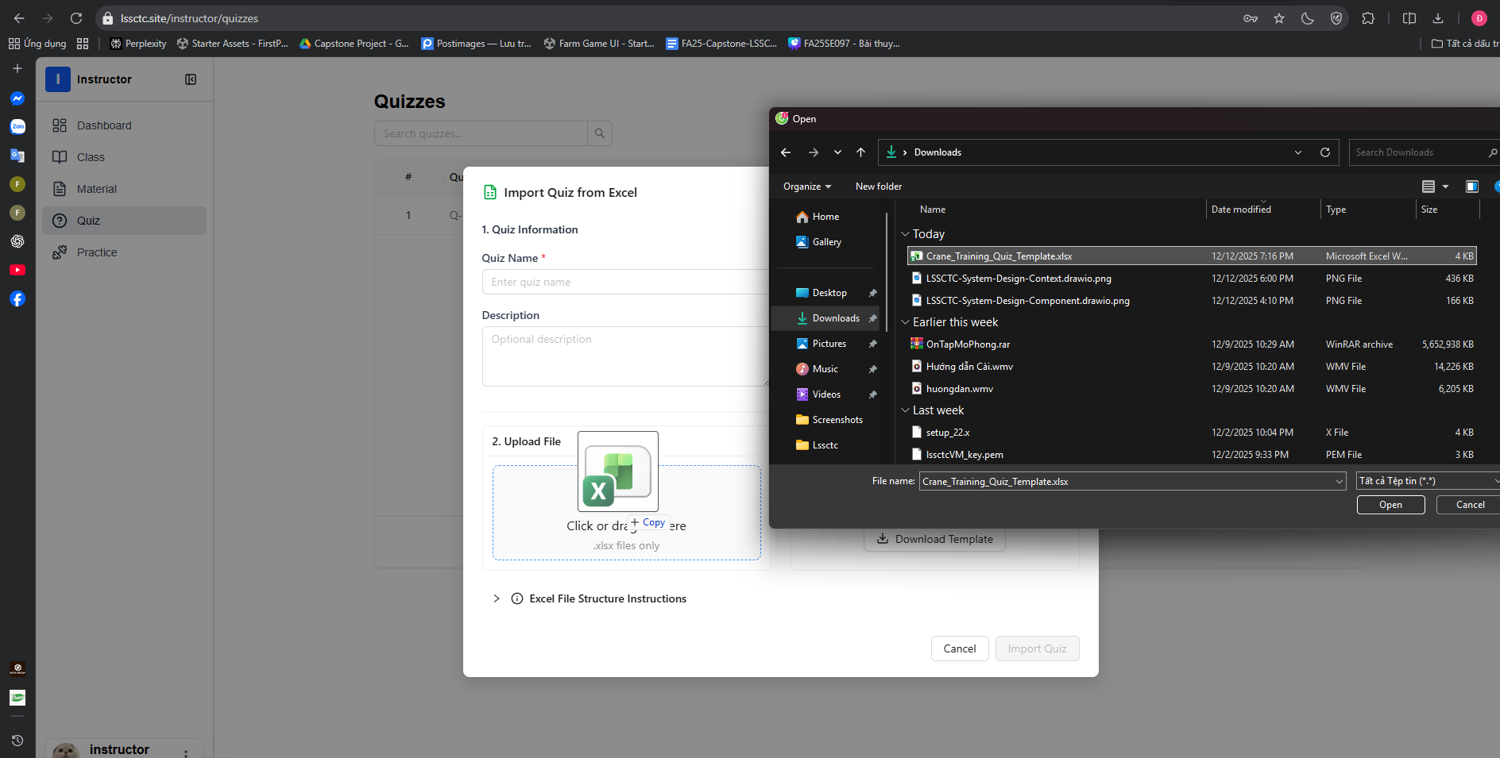

1. Drag file into drop zone or click "Browse Files"
2. Select your filled Excel file
3. File name appears in dialog

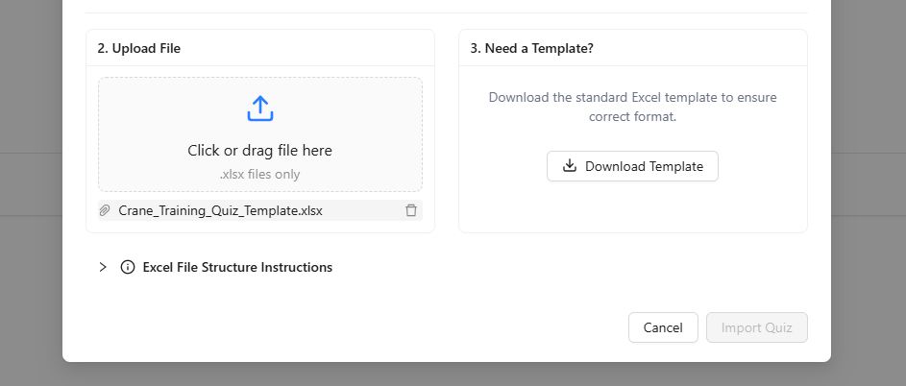

#### f. Feature 5: Simulation Practice

1. Download file exe

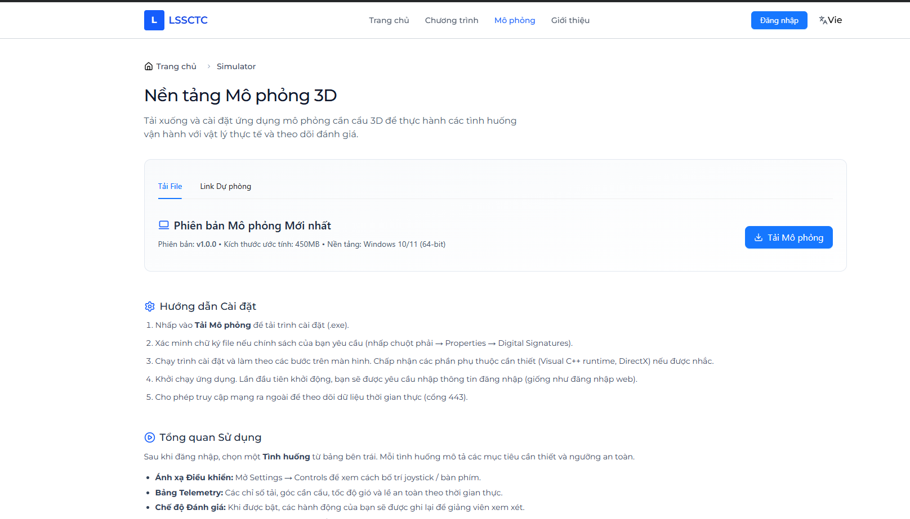

2. Open CraneSimulator.exe file

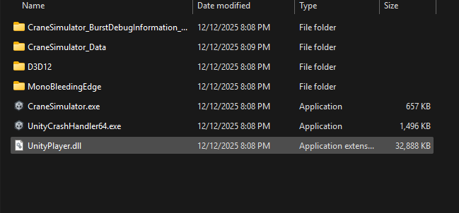

3. Login with username, password

  
 4. Select practice mode



5. Select Class

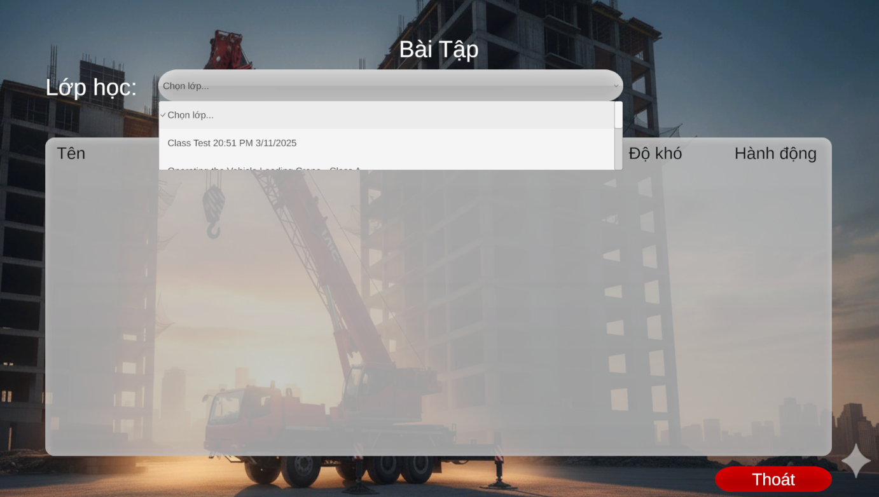

6. Select practice to start

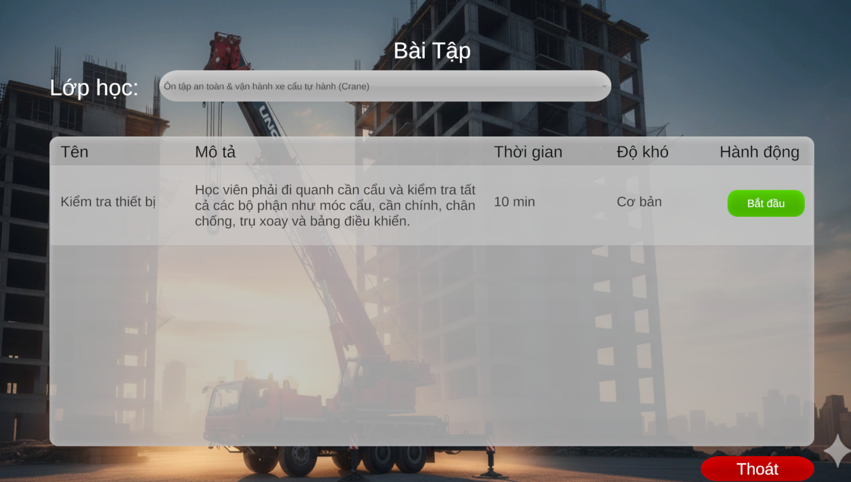

7. Finish practice